
Software Engineering Department
Braude College

Capstone Project Phase B – 61999

Temporal identifying of influential nodes
in complex citation networks

25-1-R-18

Students:

Oren Baranovsky oren.barnovsky@e.braude.ac.il
Anna Garmash Anna.Garmash@e.braude.ac.il

Supervisors: Dr. Renata Avros
Prof. Zeev Volkovich

Git: https://github.com/orenbara/influential_nodes

Table of contents

Abstract 4
1. Project review 4
1.1. Introduction 4
1.2. Background and related work 5
1.2.1. Node centrality 5
1.2.2. Gravity Models 10
2. Project description 18
2.1. System goals 18
2.2. Achieving the goals 18
2.3. Dataset description 19
2.4. Model verification 19
2.5. Potential users 19
2.6. The research procedure 19
2.7. Algorithmic approach 20
2.7.1. Data set preprocessing 20
2.7.2. Graph representation 20
2.7.3. Local Gravity model 21
2.7.4. Effective Distance Gravity model 21
2.7.5. PageRank Gravity model 24
3. The challenges during the research 25
3.1. Designing a flexible and extensible architecture 25
3.2. Dataset selection 25
3.3. Handling edge direction for references 25
3.4. Reducing plot complexity 25
3.5. Limitations of eigenvector centrality in citation graphs 26
3.6. Efficient implementation of the EffG model 26
3.7. Memory challenges and efficient representation 27
3.8. Path-based effective distance computation and memorization cache 27
3.9. Depth limitation in effective distance calculation 28
4. Results 30
4.1. Generation of importance scores 30
4.2. Standard deviation calculation and selection of top varying papers 31
4.3. Score normalization 31
4.4. Use of Min-Max vs. Graph-Size normalization for studying the influence dynamics 34
4.5. Insights from Local Gravity vs. Effective Distance Gravity models 35
4.6. Insights from Local Gravity vs. PageRank vs. PageRank Gravity models 37
4.7. Nature of academic papers in citation network 42
5. User interface description 44
6. User guide 46
7. Maintenance guide 50
8. Conclusion 56
9. References 57
10. Appendix: program code 60

Abstract

This paper explores different methods that make use of Newton’s gravity model to calculate the importance scores of nodes in a growing citation network. The importance scores are required to identify special behaviors of documents, like exponential growth in interest, clustering around subjects, and an increase in authority. Three different models were chosen for the research. Local Gravity is the first model, utilizing the degree, shortest path, and truncation radius, which provides scores for all the nodes in the graph. The second model utilizes Effective Distance, which was introduced in the disease spreading area and derived from the probability of disease spread in the network. The third model is PageRank Gravity. Unlike earlier methods that primarily assigned importance based on popularity—measured by the number of links—PageRank determines a node's authority and importance based on the quality and importance of its linked neighbors. For each document, the results are stored and analyzed using tools like graph visualization and statistical methods.

Project review

Introduction

Complex networks are a quickly growing field of study. Researches in this area come from fields like mathematics, computer science, physics, biology, epidemiology, sociology, and more [1]. Thus, the results are both theoretically important and practical in these areas. Citation networks are a type of complex network where nodes represent academic papers and edges signify citation relationships between them. These networks are necessary for studying how knowledge spreads across various scientific fields.

The identification of the most influential nodes in a complex citation network is essential for revealing scientific trends. In particular, recently published works with fast-growing citations may point to a new and relevant idea. Moreover, this approach can be applied in order to improve educational resources. Understanding which works have the greatest impact can help both lecturers and students select key materials for reading or learning.

The existing research articles that study the influential nodes often apply their models to social, collaborative, transportation, technology, infrastructure, communication, or epidemic-spreading networks [2]. However, the use of these methods on citation networks still remains unexplored. Traditional methods mostly work with static networks and do not consider the temporal dynamics of node influence. Nevertheless, in real-world networks, node influence changes over time [3].

This research’s goal is to apply existing models for studying influential nodes to the citation graph and examine how effective these methods are in analyzing scientific paper networks. In addition, a major focus is to investigate the dynamics of node influence over time. The impact of an article is not static in citation networks: new works can become more popular while older ones may lose relevance. Considering the temporal aspect helps us understand how and why the significance of nodes changes.

Background and related work

A lot of research has already been applied to the topic of identifying influential or important nodes in a complex network. In this research, we apply Gravity models to citation networks to find and observe the influential nodes. In the following section, we will discuss the existing Centrality methods and Gravity models.

In a directed graph $G = (V,E)$ , V represents the set of nodes and E represents the edges. The number of nodes in the graph is n, where $n = |V|$. A is the adjacency matrix of G, $A = \{aᵢⱼ\}$, where $aᵢⱼ$ = 1 if there is an edge between node i and node j.

Node centrality
A node's centrality in a graph measures its importance or influence within the network. Different centrality metrics capture different aspects of importance based on local and global information. Local information might include properties of a node, like in-degree, out-degree, k-shell value, H-index, and more. The global information refers to properties that describe the structure such as network size, density (number of existing edges compared to the number of possible edges), diameter (The longest shortest path between any two nodes in the graph), average path length (The average of the shortest paths between all pairs of nodes), degree distribution: The statistical distribution of node degrees across the graph.
Centrality measuring might include local, global, or hybrid information in the calculation. Next are some known centrality measurement methods for a node.
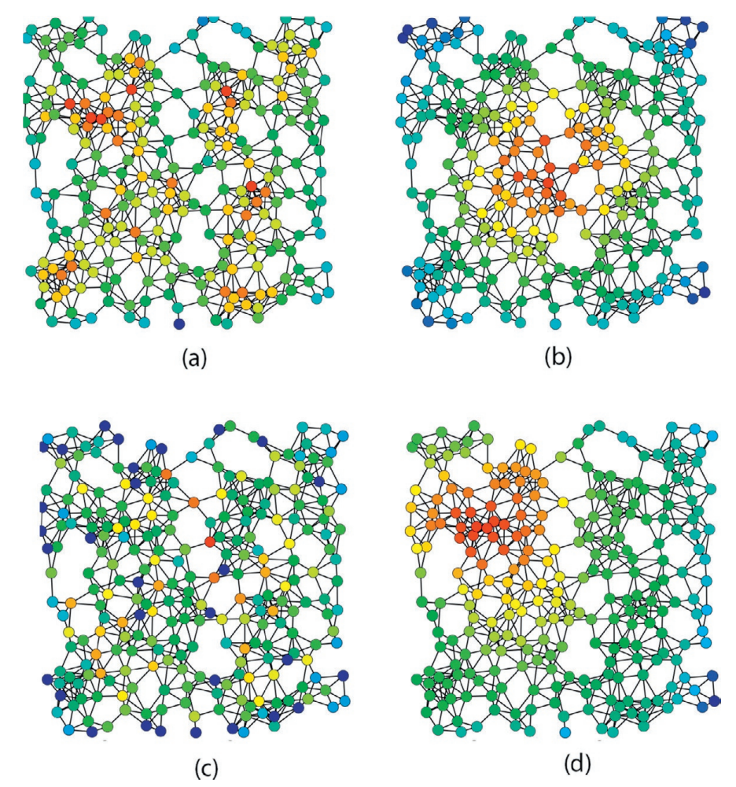
Figure 1. Red nodes are more central and blue nodes are less central. Version (a) is degree centrality, (b) uses closeness centrality, (c) shows betweenness centrality, and (d) is eigenvector centrality. This visualization is adapted from Claudio Rocchini. [15]

Degree centrality
$$DC(i) = deg(i)$$

Nodes with a high degree of centrality are influential because they interact with many others [16].
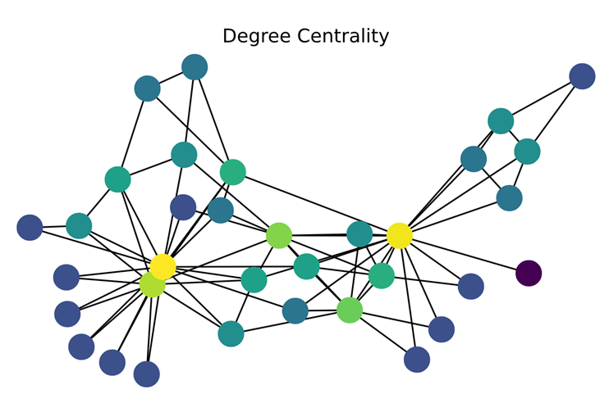
Figure 2. Green and yellow nodes are more central and blue nodes are less central. [17]

Degree centrality is a straightforward and efficient metric. Due to its simplicity, in some cases, it fails to identify the most influential nodes.
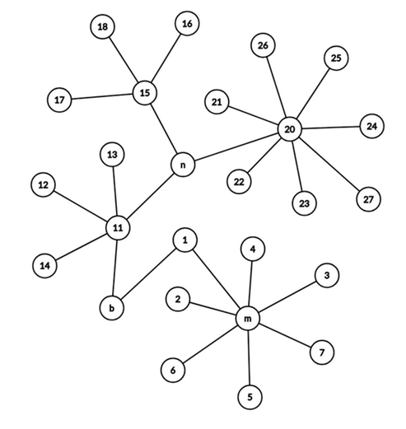
Figure 3. Although n has a lower DC than m, in some networks, n is considered much more important than m.

Betweenness centrality

Measures the importance of a node by the number of shortest paths through it [18].

$$BC(i) = \sum_{j,k≠i}{\frac{N_{jk}(i)}{N_{jk}}}$$

where $N_{jk}$ represents the number of shortest paths from node j to node k, and $N_{jk}(i)$ includes only the paths which contain i.

Nodes with high betweenness centrality control communication between different parts of the network.

Betweenness is, in some sense, a measure of the influence of a node over the information spread through the network or the expected load of a node in a transportation network [16].
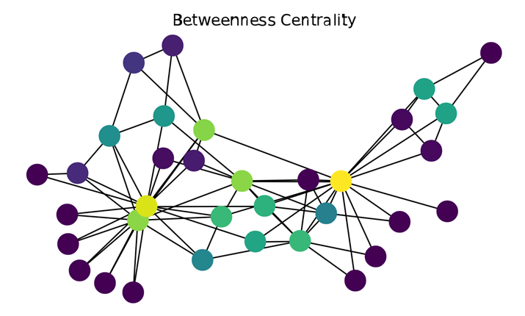
Figure 4. Green and yellow nodes are more central and blue nodes are less central. [17]

Closeness centrality

Evaluate centrality using the reciprocal of the sum of shortest paths [16].
$$CC(i) = \frac{1}{\sum_{j}^{N}{d_{ij}}}$$
where $d_{ij}$ denotes the shortest length of path between node i and node j.
Nodes with high closeness centrality can quickly interact with all other nodes in the network. Closeness can be considered a measure of how long it will spread information from a given node to other reachable nodes in the network [16].
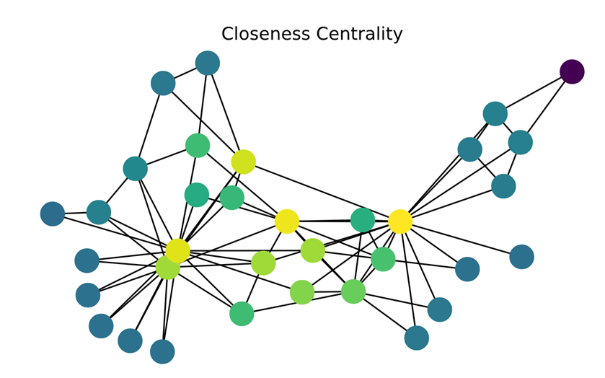
Figure 5. Green and yellow nodes are more central and blue nodes are less central. [17]

Eigenvector centrality

Assigns higher importance to nodes that are connected to other influential nodes [19].
$$EC(i) = \frac{1}{λ}\sum_{j=1}^{n}{(a_{ij}x_{j})}$$
The largest eigenvalue of A is represented by λ and $x_{j}$ is the value of j-th entry of the eigenvector corresponding to λ.

Nodes with high eigenvector centrality are connected to other high-centrality nodes, making them globally influential.

A node may have a high degree score but a relatively low Eigenvector Centrality score if any connections are with similarly low-scored nodes. Also, a node may have a high betweenness score but a low Eigenvector centrality score because it might be distant from the power sources in the network.
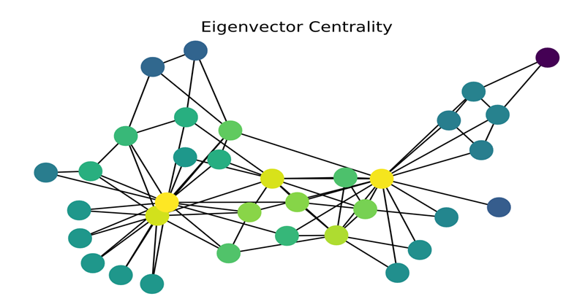
Figure 6. Green and yellow nodes are more central and blue nodes are less central. [17]
Quantifying the node's centrality, which represents connectivity to important neighbors based on the eigenvector's corresponding value, is unintuitive. Understanding the following algorithm of node centrality calculation is the key to understanding the correlation between eigenvectors and the centrality discussed. Since important nodes gain their power from neighbors with high degrees, the importance of all nodes will be calculated in an iterative process. In each iteration, the Centrality Degrees of all the neighbors of node i will be summed, and this value will replace the importance score from the last iteration. As the iterations progress, the score grows, and thus, at the end, the scores are normalized so that the largest score is 1. Following this algorithm, and after final normalization, the vector representation of the scores converges to the eigenvector corresponding to the highest eigenvalue of the adjacency matrix.

The following example illustrates this approach:
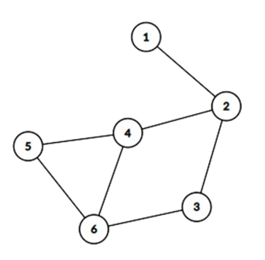
Figure 7. Example of a simple graph.

The highest eigenvalue of the adjacency matrix of the graph in the example above corresponds to the eigenvector: [0.31, 0.79, 0.69, 1.00, 0.78, 0.97].

When applying the algorithm with four iterations before normalizing the scores, the results of the scores are as follows:

Table 1. Nodes’ scores by algorithm.
 | 0 | 1 | 2 | 3 | 4
1 | 1 | 1 | 3 | 6 | 17
2 | 1 | 3 | 6 | 17 | 38
3 | 1 | 2 | 6 | 13 | 37
4 | 1 | 3 | 8 | 19 | 52
5 | 1 | 2 | 6 | 15 | 39
6 | 1 | 3 | 7 | 20 | 47

The 4th score vector is [17,38,37,52,39,47] and the normalized vector is [0.32, 0.73, 0.71, 1.00, 0.75, 0.90].

The result is similar to the eigenvector:
Eigenvector: [0.31, 0.79, 0.69, 1.00, 0.78, 0.97]
Algorithm result: [0.32, 0.73, 0.71, 1.00, 0.75, 0.90]

Using algebraic Spectral decomposition, it could be proven that this algorithm converges to the eigenvector.

Gravity Models

Gravity models introduce an innovative approach to measure the influence or importance of a node. The intuition for these models is inspired by Newton's law of universal gravitation, where the gravitational force between objects depends on their mass and distance. The formula is:
$$F = G⋅\frac{m_{1} ⋅ m_{2}}{r^{2}}$$
where F is the gravitational force, G is the gravitational constant, $m_{1}$ and $m_{2}$ are the masses of the objects, and r is the distance between their centers.

In the context of gravity models beyond physics, each model redefines “mass”, “distance” and the “gravity coefficient” based on the elements it considers important. This concept was first introduced at [20]. The intuition behind gravity models lies in their ability to capture interaction potential. Entities with larger “mass” apply a stronger pull on each other, while greater separation decreases interaction strength. This balance between mass and distance reflects a universal principle of how connections are influenced by size and proximity.

Gravity models are particularly effective for analyzing networks because they can capture the balance between node importance (“mass”) and their relationships (“distance”). The flexibility of redefining parameters makes gravity models adaptable to different domains. This makes them ideal for understanding complex networks because they provide insights into both local and global network behavior.

Classic Gravity Model

A classic version of Gravity calculation for a node in the graph.
$$G(i) = \sum_{i≠j}{\frac{k_{i}* k_{j}}{{(dist}_{ij})^{2}}}$$
where $k_{i}$ is the degree of node i and ${dist}_{ij}$ is the shortest distance between nodes i and j.
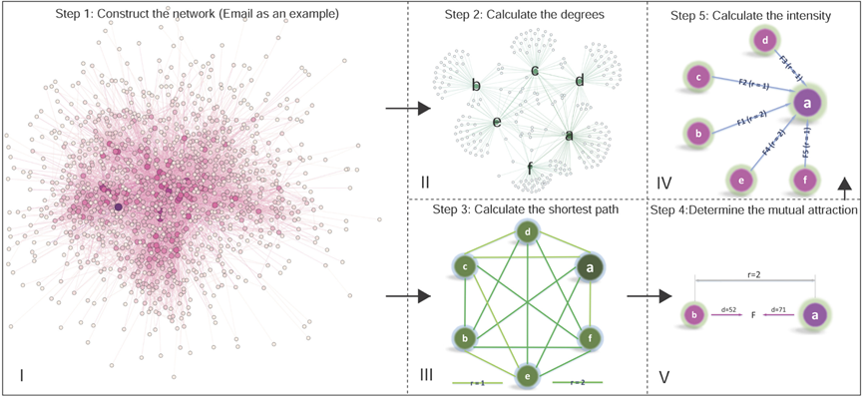
Figure 8. The flow chart of the Classic Gravity Model. [21]

Local Gravity Model

When nodes are located far away, their gravitational force is weak. The Local Gravity Model suggested by Li et al. [22] allows for simplifying the calculations by limiting the amount of distance calculation only to nodes of predefined distance R.
$G_{local}(i) = \sum_{{dist}_{ij}<R}{\frac{k_{i}* k_{j}}{{(dist}_{ij})^{2}}}$
where R is the truncation radius and is often set to half of the average length of the shortest path.

Clustering Gravity Model

Li et al. [23] proposed to redefine the mass: use $Sp(i)$ instead of node degree $k_{i}$. This model allows quantifying the effect of nodes with large clustering (neighbor connectivity).
$$G_{clustering}(i) = \sum_{{dist}_{ij}<R}{\frac{Sp(i) * Sp(j)}{{(dist}_{ij})^{2}}}$$
$$Sp(i) = e^{-αC_{i}}* k_{i}$$
$$C_{i} = \frac{2n_{i}}{k_{i}(k_{i}-1)}$$
where $α$ is a configurable parameter, $n_{i}$ that denotes the number of edges between neighbors of node i.

Network Embedding Gravity Model

This model was suggested in [24] and modifies the distance by embedding the nodes into low-dimensional vectors in Euclidean space.
$$F_{ij} =\frac{k_{i}* k_{j}}{{(Euc}_{ij})^{2}}$$

Random Walk-Based Gravity Model

Most gravity models have an expensive time complexity of finding the shortest distance between all nodes, $O(|V^{2}|)$ according to the complexity of the Dijkstra algorithm. The authors of the paper [25] propose replacing the shortest distance with the node’s position in a random walk, reducing the complexity.

Random Walk

Random walk on a graph is a walk strategy where it starts from the node v and moves to one of its neighbors x with probability $P_{vx}$. The outcome of the process is l-length walks of each node, where the probability of visiting x from node v can be defined as:
$P(c_{i}=x | c_{i-1}= v)= \frac{π_{vx}}{0}, if (v,x)∈E$
$$P(c_{i}=x | c_{i-1}= v)= 0, if (v,x)∉E$$
where Z is a normalization constant and $π_{vx}$ – the unnormalized jumping probability between nodes v and x.
Jumping probability indicates how likely it is for the walker to jump from one node to another. Two tunable parameters are used to control how the walk explores neighboring nodes.
- p – return parameter. It measures the possibility of revisiting the node during the walk. A higher value reduces the probability of revisiting a node.
- q - in-out parameter. It controls the strategy of the walk. The strategies could be, for example, Breadth-First Search (BFS) or Depth-First Search (DFS).

In addition, two more important parameters must be considered:
- γ – the number of random walks performed for each node
- l – the length of each random walk
Choosing the correct value for γ determines the measure of graph coverage during random walks. As γ increases, the graph is explored more fully, meaning that more random walks are performed for each node. A similar principle applies to the parameter l. Increasing the walk length allows the exploration of more distant parts of the graph, providing a more detailed understanding of its structure and relationships.

Gravity model based on random walk

The input data for the algorithm are pre-generated random walk samples. For each node, starting from the second position in each random walk sample, the algorithm calculates the gravity value based on:
$G_{RWG}(i) = \frac{g(i)}{γ⋅(l-1)}$

with $g(i) = \sum_{m=1}^{γ}{\sum_{j=2}^{l}{\frac{k_{i}⋅k_{j}^{m}}{{(j-1)}^{2}}}}$

where $k_{j}^{m}$ is the degree of j-th (position) node in the m-th walk. γ is the number of walks for each node and l is the length of the walk.
It is important to note that the value j-1 is used because it means the distance (the number of steps) from the source node to the j-th node. This is the replacement for the shortest distance, as mentioned earlier.

Effective Distance Gravity Model

An [26] Effective Distance was introduced to replace the geographical distance of the paths connecting nodes of cities to predict the time in which a disease will spread to a target city. In [26] Effective Distance revealed complex hidden patterns of the network, which provided more accurate information for the task given compared to the physical geographical distance.

In [27] Effective Distance was merged into the Gravity Model as the distance between two nodes, replacing the Euclidean distance and shortest path distance. Effective Distance [27] is a distance calculated from the probability, which reveals the hidden pattern geometry of the network.

The effective distance from node m to node n, which are directly connected, is defined as:
$$D_{n|m}= 1 - log_{2}(P_{n|m})$$
where $D_{n|m}$ is the value of the effective distance from node m to node n if they are directly connected. $P_{n|m}$ is the probability of moving from node m to node n.
$$P_{n|m}= \frac{a_{mn}}{k_{m}} , ( m ≠ n)$$
where $k_{m}$ is the degree of node m and $a_{mn}$ is the element corresponding to the edge between m and n (1 if there is an edge between m and n).
Effective Distance is asymmetric, meaning that $D_{n|m}≠ D_{m|n}$ .
Effective Distance of distant nodes

The effective distance of nodes that are not directly connected can be obtained transitively.
$$D_{3|1}= D_{2|1} + D_{3|2}$$
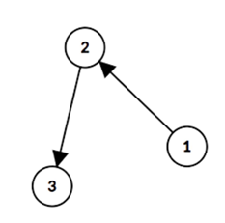
Figure 9. Example of indirect connection.

Distance of nodes with multiple path options

The shortest path is chosen if there are multiple paths from node m to point n.
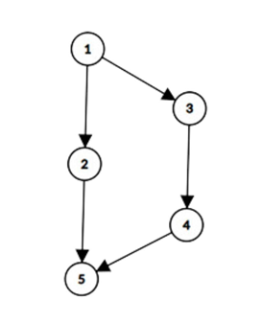
Figure 10. Example of multiple paths.

If there are no weights, then the path { $D_{2|1} + D_{5|2}$} will be chosen.

Effective Distance is asymmetric

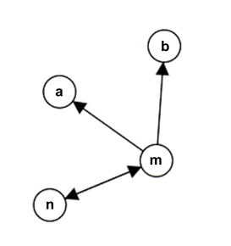
Figure 11. Example of asymmetric relationships.

$$P_{n|m}=\frac{1}{3} , D_{n|m} = 1 - log_{2}\frac{1}{3}$$
$$P_{m|n}=\frac{1}{1} , D_{m|n} = 1 - 0$$

[27] To identify important nodes in real-world networks, it is insufficient to consider only local and global node information; moreover, it is not enough to consider static and dynamic information. Often, there is hidden structural information about the interaction between nodes, which is important for measuring the importance of nodes.

Effective Distance Gravity Model (EFFG)

This model was introduced in [27] to calculate the importance of nodes in real-world networks.
$W_{interaction}(i,j) = \frac{k_{i} * k_{j}}{D_{j|i}^{2}}$
$${ C}_{EffG}(i) =\sum_{j=1, j≠i}^{N}{W_{interaction}(i,j)=\sum_{j=1, j≠i}^{N}{\frac{k_{i} * k_{j}}{D_{j|i}^{2}}}}$$
where $k_{i}$ and $k_{j}$ are the degrees of node i and node j respectively $D_{j|i}$ is the effective distance from node i to node j.
$W_{interaction}$(i,j) denotes the interaction score between node i and node j, which might be considered as the gravitational force in which the nodes pull each other.

Weighted Gravity Model

This method was suggested in [28] and utilizes the idea of eigenvector centrality and Truncation radius.

The weighted gravity model, also called GMM: generalized mechanical model, is proposed that uses global information and local information [28]. If the degree of one node is larger (local information), the shorter the distance and the greater the weight (global information) with other nodes, the influence of the node is greater.
$$G_{Weighted}\left(i\right)= \sum_{{dist}_{ij}<R}{e_{i}*\frac{k_{i}*k_{j}}{{({dist}_{ij})}^{2}}}$$
$$AX = λX,{ e}_{i} = X_{i}$$
where λ is the largest eigenvalue of A. X is the eigenvector. $e_{i}$ is the i-th value of X.
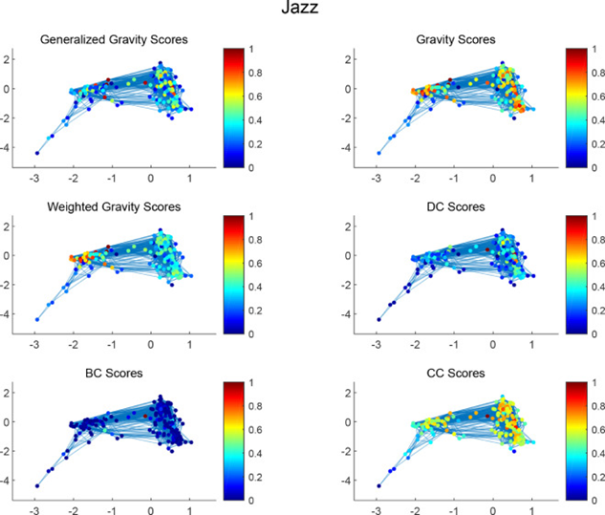
Figure 12. Gravity models applied to the famous Jass network. [29]

PageRank Gravity Model

PageRank

In many methods before, the importance of a node was determined by its popularity. Popularity in terms of citation network is quantified by the number of edges the node has [11]. In PageRank, the idea of authority is introduced.

The idea that PageRank brought up was that the influence of any web page can be derived from pages that link to it. If web page i is created, and i has a hyperlink to web page j, this means that j is considered important and relevant for the topic i introduces. If there are a lot of pages that link to j, this means that the common belief is that page j is important. On the other hand, if j has only one backlink, but that comes from an authoritative site k, so k transfers its authority to j; in other words, k asserts that j is important [30].

PageRank provides a more sophisticated method for doing citation counting. PageRank is interesting because there are many cases where simple citation counting does not correspond to common-sense notions of importance. For example, if a web page has a link to the Yahoo home page [31], it may be just one link, but it is a very important one. This page should be ranked higher than many pages with more links [11].

Understanding PageRank:
Let p be a web page. Then let $B_{p}$ be the number of pages that point to p. $N_{p}$ is the number of links from p, and c normalization factor. The first formula is a simplified version of PageRank:
$$R(p) = c\sum_{v∈B_{p}}{\frac{R(v)}{N_{p}}}$$

$N_{p}$ is the number of nodes that point to p. $c < 1$ since some pages have no forward links and their weight is lost.

Relation to eigenvectors:

Let A be a square matrix with the rows and columns corresponding to web pages. Let $A_{p,v}=\frac{1}{N_{p}}$ if there is an edge from p to v, and $A_{p,v}=0$ if not. If R is treated as a vector over web pages, then R = cAR. So, R is an eigenvector of A with eigenvalue c.

The Random Surfer Model

The Random Surfer model is another way to look at the Random Walk. The model aims to best represent the behavior of website visitors and calculates a probability of a random user visiting a webpage [32]. The surfer is clicking on links at random, and the probability of the surfer clicking on a link in a page depends on the number of existing links [32]. The surfer is clicking on links, and each page counts the number of visits it gets from the surfer. After many iterations, the process converges, and each page has its percentage. There is a problem with this method – there are parts of the network which are not connected, and thus the surfer needs to randomly jump to another section of the network.

PageRank Gravity Model
$$PRG(i) = \sum_{i≠j}{R(i)*\frac{k(i) * k(j)}{{(dist}_{ij})^{2}}}$$
where R(i) is the PageRank score of node i and ${dist}_{ij}$ is the shortest distance between nodes i and j.

The PageRank Gravity (PRG) model builds on the traditional PageRank scores, that was previously explained. This formula captures the idea that highly ranked nodes exert a stronger influence.

Project description

System goals

The research is conducted to find out whether gravity centrality measurements provide interesting results when applied to citation networks, which are changing as time progresses. To achieve the goals, a program is designed to handle the computation of many different models. Each model provides scores for the studied papers in the given dataset. The scores for each year are stored, and results reflect the change in scores for chosen nodes. Comparisons of the different models’ results and application of statistical tools provide the ability to produce conclusions.

To accomplish the main goals, which were described above, technical and more specific goals are defined for the system. The system should support different datasets so that results can be tested on different environments. Different models should be executed easily by the researchers, and the results should be clear. Each model should output both numerical and graphical results. Optimization for calculation is required, since in many cases, large datasets are used, and some models perform very intensive computations. To be able to provide the user with a tool that will allow him to focus on the research itself and not on technicalities, a graphical interface and a set of utility functions are required. Another important aspect of the project is quick implementation.

The main goal is to answer the question about Gravity Models, which was discussed above, and it requires comparisons and analysis of the results.

Achieving the goals

The Python programming language was chosen for the system. Python allows quick implementation; moreover, Python includes lots of open-source libraries that provide optimized tools for working with graphs. The Gravity models are based on well-known centrality methods. Centrality methods, such as Degree Centrality, Eigenvector Centrality, Betweenness Centrality, and many more, are already implemented and optimized by the NetworkX Python library [1]. Graph implementation with all the required utilities, like degree calculations, transposing, and more, is also implemented in an optimized manner by NetworkX. Well-known graphical plotting libraries like Matplotlib [5] and Plotly [6] provide tools for displaying and working with results. Developing a GUI (graphical user interface) is a much more manageable task when using Python’s built-in TKinter library [7]. The main components of the system are the GUI and the Influence Engine.

The GUI uses TKinter to create multiple sections for the researcher. The first section provides an interface for choosing the model, providing the data set, setting parameters, and starting the execution. The second section provides vision to the inner loggings of the engine while executing model calculations. The third section contains the graph with the score results of the chosen papers over the years.

Another system component, Influence Engine, is stored as a separate file within the same project and contains a class and its methods, which are responsible for executing the chosen model. This class is instantiated by the GUI thread and is executed separately to allow the user to use the GUI while the model is executed. The engine supports three data sets currently. Adding additional data sets, models, or plotting mechanisms is possible.

Dataset description

The supported data sets cover a variety of scientific fields. The DBLP data set [8] focuses primarily on computer science publications, providing bibliographic information on journal articles, conference papers, and other research outputs. The Cit-HepPh data set [9] represents citation relationships between papers in phenomenology of high energy physics, while Cit-HepTh [10] contains citations for papers in theory of high energy physics. These data sets serve for evaluating citation network analysis and studying papers' importance for the research.

Model verification

There are multiple approaches for calculating importance scores in a citation network. The goal of model verification is to evaluate and compare the results produced by traditional centrality methods with gravity-based models. It allows us to analyze the similarities, differences, and potential advantages offered by gravity-inspired approaches.

To support this comparison, the system integrates both standard centrality algorithms provided by the NetworkX library and custom implementations of gravity-based models: Local Gravity, PageRank Gravity, and Effective Distance Gravity. This modular approach allows verifying different modules.

Potential users

The program is originally designed to explore the application of gravity models in citation networks. It is built with a modular architecture that allows easy integration of additional datasets and models. Although the initial focus is on citation networks, any dataset that can be converted into a graph structure may be used. Similarly, any model that accepts a graph as input and produces scores for the nodes can also be incorporated.

The research procedure

In order to evaluate whether gravity models are an effective tool for calculating the importance of papers in temporal citation networks, extensive experimentation was required. This involves running the models on different datasets, adjusting parameters, and comparing the results, all of which could be done once the system functions correctly.

After selecting the overall design, the first prototype was developed to test the gravity models against traditional centrality algorithms that are commonly used today for measuring node importance in graphs. Following these initial tests, the system was expanded to include multiple implementations of gravity-based models.

Some of the outcomes aligned with the expectations of the supervising professors, while others produced unexpected and surprising results. It became clear that further analysis was necessary to better understand these outcomes, which required refactoring and extending the code. Additional parameters were added to the system to allow fine-tuning of the models' behavior. In some cases, parameter adjustments brought the results closer to expectations, while in others, the results remained unchanged.

To improve the productivity of the research process, the system was updated with a graphical user interface (GUI), allowing easier configuration, execution, and management of calculations. This made it easier to save different experiment settings and re-execute the analysis with different settings.

Algorithmic approach

Data set preprocessing

Currently, three data sets are supported by the system: DBLP, Cit-HepPh, and Cit-HepTh. Adding more data sets is a modular process that requires a small addition to the source code.

The importance score calculation is executed by the engine. The centrality methods, which the gravity models are based on, accept graphs as input. In most cases, the citation networks are stored in formats like CSV or JSON, so converting the data into a graph is required. The engine's main task is to calculate scores and produce results throughout the years. Each node in the graph has to contain a unique paper ID, a publishing year, and reference attributes. References have to be a collection because the edges are added to the graph between the paper and the papers it references.

When all the requirements are met, the engine will build the dictionary from the papers in the dataset. The dictionary is designed with years of paper writing as keys and the attributes of the papers, which are required for the graph, stored as values within dictionaries.

Graph representation

The implementation is based on the use of a DiGraph object from the NetworkX library, which is designed to represent directed graphs [2]. A DiGraph stores nodes and edges with optional data or attributes. Edges are represented as links between nodes with a defined direction between them.

Before adding the nodes and edges to the graph, the dictionary of papers is sorted based on the year. The sorting allows incremental addition of papers as nodes and their references as edges. An edge will be added from the paper to its reference only if the reference exists in the graph already. Since the dictionary is sorted, a paper that is referenced will be added before the referencing paper.

The direction of the edge has importance in citation networks. Many centrality methods require the direction of the edge to be from the referencing paper to the paper that is referenced, but in other cases, it might be reversed. To be able to work with different methods, the graph is transposed using NetworkX's built-in transpose method.

Local Gravity model

Truncation radius

Instead of considering the entire network when calculating influence, which may include many distant or weakly connected nodes and add unnecessary noise, the Local Gravity model focuses on the local neighborhood of each node. To do this, it first calculates the shortest paths from the node to all other nodes it can reach by using the method [13] from the NetworkX library. Then, it computes the average of these path lengths (ignoring the distance from the node to itself). The model sets the truncation radius as half of this average.

Gravity score computation

For each node in the citation network, the algorithm calculates a gravity score by multiplying its out-degree by the out-degrees of its nearby neighbors and dividing by the square of the shortest path distance between them. Only the nodes that are close enough (inside the truncation radius) are included in the calculation.

Effective Distance Gravity model

Converting a graph to an adjacency matrix

The first step in the EffG pipeline is converting the directed graph G into its adjacency matrix representation. This step is essential because the Effective Distance Gravity Model operates directly on adjacency matrix values and not on the graph structure itself.

An adjacency matrix is a square matrix A used to represent the direct connections between nodes in a graph. For a graph with N nodes, A is an N × N matrix where each entry Aij indicates the directed edge from node i to node j (Aij is 1 if paper i cites paper j, otherwise 0).

In the code implementation, the building of the adjacency matrix is made by a method from the NetworkX library that returns the adjacency matrix of the inserted graph G [3]. The result is a binary matrix that captures the citation structure of the dataset.

Degree Calculation

The degree calculation for each node in the EffG model is made from an adjacency matrix. In the context of a citation graph, this corresponds to counting how many references each paper makes. The degree is calculated by summing across each row of the adjacency matrix. For example, for a given node i, the degree is the sum of all values in row i of matrix A, representing the number of directed edges going from node i.

Transition probability calculation

The algorithm computes a transition probability matrix from a given adjacency matrix. It uses a vectorized matrix multiplication that allows getting the required result without using nested loops and significantly improving the performance.

The transition probability is defined as:
$$P_{n|m}= \frac{a_{mn}}{k_{m}}$$
where $k_{m}$ is the degree of node m and $a_{mn}$ is the corresponding element in the adjacency matrix.

The algorithm proceeds by the following steps:
- Safe degree handling: all nodes with zero out-degree (isolated nodes) do not actually have outgoing transitions, but their degrees are temporarily set to 1 to avoid division by zero and mathematical errors. At the end, these nodes will be handled correctly because their rows in the probability matrix remain 0.

- Creating inverse degree diagonal matrix: a diagonal matrix D⁻¹ is constructed by the way where each diagonal element is $\frac{1}{k_{m}}$.

- Computing the transition probabilities: the operation performs matrix multiplication $P =D^{-1}A$, which ensures that each row of the adjacency matrix is divided by the corresponding node’s degree.

- Removing self-loops: in the citation graph, the paper cannot cite itself, so the diagonal of matrix P is filled with zeros.

Finding effective distance

The function implements a recursive depth-limited search to compute the minimum effective distance from a source node to a target node in a citation graph, using the transition probability matrix derived from the graph structure. The algorithm computes effective distance only along valid paths from node to node. If no path exists, the distance is considered infinite.

Base cases that stop the recursion:
- If the distance has already been calculated between two nodes, it is returned immediately without redundant calculations.
- Self-distance is set to 0.
- For directly connected nodes, the effective distance is computed from the transition probability by using the formula:
$$D_{n|m}= 1 - log_{2}(P_{n|m})$$
- If the search exceeds the predefined maximum recursion depth limit, it stops and returns infinity.

Otherwise, if no directed path exists, the algorithm starts recursive exploration. It explores all outgoing neighbors of the current start node. For each neighbor, it checks if a valid path exists from that neighbor to the target node. If no such path exists, recursion stops early with an infinite result. If a valid path exists, the algorithm computes the effective distance to the neighbor and then recursively computes the minimum effective distance from the neighbor to the target node. At the end, the minimum effective distance is returned.

Interaction scores computation

The function computes the measure of interaction strength between pairs of nodes. Firstly, the algorithm filters the effective distance matrix to identify valid node pairs for which an interaction score can be meaningfully computed. The resulting mask identifies all meaningful pairs for which the effective distance is not infinite (meaning a path exists between the pair nodes). In addition, it ensures that self-distances are excluded, because they are not relevant for the computation.

After the extraction of the indices of the valid pairs, the algorithm computes the interaction scores $W_{interaction}(i,j) = \frac{k_{i} * k_{j}}{D_{j|i}^{2}}$. The scores are computed only for valid pairs and with the usage of the vectorized method that avoids explicit loops. The resulting matrix represents a sparse interaction scores matrix.

PageRank Gravity model

Handling sparse graphs

Before starting any calculations, the algorithm verifies if the graph has few edges. This check ensures the graph has enough connections to allow meaningful PageRank computations. If the graph is too sparse, the algorithm skips further processing and assigns a gravity score of zero to all nodes.

PageRank calculation

PageRank is calculated for all nodes using the damping factor, which determines the probability of continuing along outgoing edges versus jumping to a random node. In the implementation, the PageRank scores are computed using the function [14] provided by the NetworkX library.

Shortest path computation

The algorithm computes the shortest path lengths between all pairs of nodes to determine the minimum number of edges required to reach one node from another. In the implementation, shortest paths are calculated using the function [4] provided by the NetworkX library. After collecting all shortest path lengths, the algorithm flattens all distances into a list. This list of distances is used to compute the maximum shortest path length for reference.

Gravity score calculation

For each node, the algorithm calculates a PageRank gravity score by adding up the influences it receives from all other reachable nodes. The influence between two nodes depends on both of their PageRank values and the distance between them. The influence from node j to node i is calculated by multiplying their PageRank scores and dividing by the shortest path distance (raised to the power of k). Only nodes that are not the same and are reachable (distance greater than zero) are considered. The final gravity score is the total sum of these influences for each node.

The challenges during the research

Designing a flexible and extensible architecture

The first challenge appeared during system design. The same wrapping code must be generic enough to deal with different data sets and different models. Some datasets might load into memory while others might not; some models might require longer processing than others. To be able to support the different models and data sets, the preprocessing functionality was decoupled from the main code. Different preprocessing functionalities were written for different data sets, yet in some cases, the preprocessing functionality might be reused. For example, any data set that is built with a JSON structure and has a unique ID, publishing year, and references collection can be preprocessed with the existing function.

Dataset selection

An additional challenge was about the data set, which was chosen in Phase A of the final project. Cora was the recommended dataset, and an allegedly suitable version — which appeared to include both citation data and timestamps — was found online. However, after reviewing it more carefully, it turned out that the "citations" part was mainly about removing duplicate entries and did not provide the actual citation relationships needed for the research. As a result, a further search was carried out, and several more suitable datasets were found, including DBLP and Cit-Hep.

Handling edge direction for references

Determining the correct direction of the edges in the graph is also one of the research challenges. Different models interpret the concept of "reference" differently. In the system we used, a reference was represented as an edge going from the citing (referencing) paper to the cited (referenced) paper. This design choice was originally made to support building the graph incrementally over time, as new papers and their references were added. However, since different models have different expectations for how these edges should be oriented, we had to carefully investigate each model’s requirements and adjust the graph accordingly.

Reducing plot complexity
Another issue was the large and crowded plot produced by the system. When using DBLP version 10, which contains millions of papers, the plot became very messy and hard to read. To handle this, the analysis calculated the derivatives to measure how quickly the interest of each paper was changing. A parameter was added to limit the number of shown tracks by removing those with a below-average slope. This helped make the plot clearer and easier to understand.

Limitations of eigenvector centrality in citation graphs

In Phase A, the Weighted Gravity model based on eigenvector centrality seemed like a suitable candidate and a good option for research because it should provide high scores for papers that are cited by other important papers. However, when we tested NetworkX’s Eigenvector Centrality, the results were unexpected and not useful for further research.

After looking deeper into the topic, we discovered that Eigenvector Centrality — and therefore Weighted Gravity — is not suitable for directed graphs like citation networks. Citation networks often contain disconnected parts, while Eigenvector Centrality requires the graph to be strongly connected, meaning every node must be reachable from every other node. This is not possible in citation networks.

Luckily, the PageRank algorithm (originally developed by Google) [11] turned out to be a perfect fit. PageRank is designed to handle directed graphs and is widely used to rank web pages in search results. Like Eigenvector Centrality, it gives higher scores to nodes that are linked by other important nodes, but it also includes extra parameters that handle the challenges of citation networks. PageRank is based on the leading eigenvalue of the graph’s adjacency matrix, which makes it a suitable replacement for the Weighted Gravity model based on Eigenvector Centrality.

Efficient implementation of the EffG model

The main engineering challenge in the implementation of the Effective Distance Gravity model is to ensure that the runtime remains practical even for slightly large-scale citation networks. The challenge is related to the computational performance of nested loops in Python.

Python, unlike compiled languages such as C or Java, is an interpreted language. Interpreted languages typically run slower compared to compiled languages because the interpreter translates the source code into intermediate code during runtime. That is why loop operations in Python are inherently slower due to high-level abstraction, dynamic typing, and interpreter overhead.

Specifically, using nested “for” loops to iterate over all node pairs or matrix entries in a graph with thousands of nodes leads to exponential growth in execution time, making the algorithm impossible for practical use.

To overcome this problem, the code is built with the use of vectorized solutions, which give faster implementation. Vectorization allows replacing element-wise “for” loops, where it is possible, with matrix multiplications, masked indexing, and sparse matrix operations. These techniques enable the model to reduce the runtime.

Memory challenges and efficient representation

Memory consumption is a significant issue in Effective Distance Gravity model implementation. It requires the creation and manipulation of several large matrices, including the adjacency matrix, the effective distance matrix, and the transition probability matrix. Their structure is inefficient, but these matrices are fundamental to the algorithm.

These matrices are large because they are structured to represent pairwise relationships between all nodes in the network. In a citation network with N nodes, each matrix must include N×N entries, even if the actual number of edges is much less. For large-scale datasets where N can reach thousands or even more, these matrices quickly become to include millions of entries.

However, despite the fact that the matrices are extremely large, they are mostly filled with redundant or uninformative values. These observations come from the structural properties of citation networks. In a typical citation graph, each paper cites only a very small subset of all existing papers. As a result, most node pairs are not directly connected, which leads to matrices being mostly filled with non-useful values.
For example,
- The adjacency matrix contained mostly zeros because most papers do not cite the majority of other papers.
- The effective distance matrix is mostly filled with infinity values to represent unreachable node pairs.
- The transition probability matrix similarly had a majority of zero entries, since transitions are only possible along actual citation links.

In order to deal with this memory challenge, a sparse representation was applied for all matrices. All matrices were converted to a sparse format using the Sparse array package from the Scipy library [12]. This approach allows storing only existing edges in the adjacency matrix, only meaningful transition probability values, and only finite effective distances that were computed during the process. Sparse storage ensures that zeros or infinite values do not consume memory unnecessarily. By understanding the citation network features, it is possible to apply the EffG model to slightly larger datasets without exceeding memory limitations.

Path-based effective distance computation and memorization cache

The way how effective distances are calculated in the EffG model is the critical aspect of the approach. In theory, the model should compute effective distances between all possible pairs of nodes. At the same time, in large and sparse graphs, such as citation networks, most node pairs are not connected by any path.

Moreover, the citation network is a directed acyclic graph (DAG). If paper A cites paper B, then there is a directed edge from A to B; thus, it is possible to compute a valid effective distance from A to B. However, the reverse is not true – paper B cannot cite paper A if A is a more recent publication. Therefore, there is no edge from B to A, and no path can exist in that direction. As a result, the effective distance from B to A is infinite, while the distance from A to B might be finite.

Thus, there is a conclusion that effective distance is only meaningful if there exists a valid path from node A to node B. This asymmetry can be used to improve the computational efficiency. Rather than computing effective distance from every node to every node, the implementation smartly limits the computation to node pairs that are actually reachable from one to another, using precomputed shortest path lengths [4]. This avoids spending time on evaluating distances between disconnected nodes, which would always result in infinity anyway.

The advantage of this method is not only that it reduces the number of iterations performed, but also that it reduces the number of calls to the recursive function that finds the minimum effective distance between two nodes. For each reachable node pair, the approach calls a recursive function that explores all possible paths from the source to the target, calculates the effective distance along each path, and finds the minimum effective distance among these possible paths.

To improve performance and avoid redundant computations, a memorization cache is used to store previously calculated effective distances. If a value has already been computed for a node pair, it is reused directly without recalculation.

Depth limitation in effective distance calculation

When computing the effective distance between two nodes in a directed graph in large and deep networks like citation graphs, the search for shortest effective paths can become computationally expensive. To solve this limitation, the implementation introduces a depth limitation mechanism.

During the recursive search for a path from the source node to the target node, we specify how deep the recursion can go. This is controlled by a parameter. If the number of steps exceeds this minimum allowed depth, the recursion terminates early for that path and does not continue exploring deeper branches.

In the citation network, most citations are made to papers published within a few years. This means that strong influence typically flows through short citation paths. The longer paths represent indirect and weaker relationships. Thus, the limitation improves computational efficiency by reducing the number of paths evaluated, lowering memory usage, and computation time.

This design is not only practical but also theoretically supported by the gravity model on which Effective Distance Gravity score is based. In the gravity model, the interaction strength between two nodes is inversely proportional to the square of the distance.
$${ C}_{EffG}(i) =\sum_{j=1, j≠i}^{N}{W_{interaction}(i,j)}=\sum_{j=1, j≠i}^{N}{\frac{k_{i} * k_{j}}{D_{j|i}^{2}}}$$
This means that as the distance between nodes increases, the ${D_{j|i}}^{2}$ becomes very large, so the overall contribution to the gravity score becomes very small. In other words, long-distance relationships almost do not contribute to the final score. Thus, including long paths in the computation not only increases cost but has minimal impact on the final result.

Limiting the depth of the recursion ensures that only short and relevant paths are considered and makes it possible to maintain performance and relevance.

Choosing an appropriate depth limit is also the theme of interest. When choosing an appropriate depth, the graph size and citation network characteristics should be considered. For large graphs, deeper searches are exponentially more expensive. In order to choose a suitable value of the depth parameter, several experiments should be performed with different values, while taking into account runtime and memory usage.

Results

Generation of importance scores

In order to compare the behavior of different importance models, all selected models for Influence Engine were executed on the same dataset - Cit-HepTh. This approach ensures that the comparison between models is fair and impartial. Thus, all models analyze identical data under the same conditions. The selected models for research results exploration are: In-degree centrality, Out-degree centrality, PageRank, Local Gravity model, Effective Distance Gravity model, and PageRank Gravity model.

After executing the engine, each model produced an importance score for every examined paper in the dataset for each year analyzed. These importance scores represent how significant or influential each paper is according to the logic of the specific model applied. Each model calculates importance depending on its definition. The example of the results format:

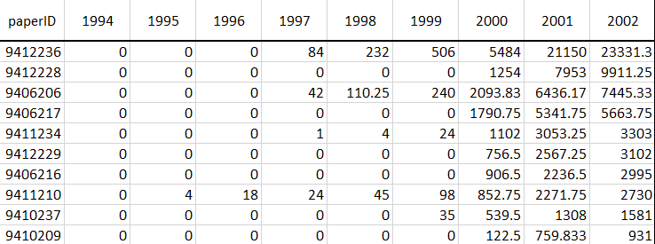
Figure 14. The example of the results format.

The table above presents an example of the output obtained from executing the analysis engine. Each row in the table corresponds to a specific paper identified by its unique ID (paperID). The columns represent the importance scores assigned to that paper in each year of analysis, e.g., the years from 1994 to 2002. For instance, paper with ID 9412236:
- This paper had no importance (score 0) in the years 1994 - 1996.
- In 1997, it started to receive an influence score (84), which increased regularly each year afterwards.

This year-by-year representation allows easy visual tracking of influence evolution. Moreover, the results serve for further statistical analysis: calculating standard deviation, normalization, etc.

Standard deviation calculation and selection of top varying papers

In order to analyze how the importance of each paper changes over time, the standard deviation (STD) of each paper’s importance scores across the years was calculated.
$$σ = \sqrt{\frac{{\sum_{i=1}^{N}{\left(x_{i}-μ\right)}}^{2}}{N}}$$
where $x_{i}$ is each data point in the set, $μ$ is the mean, and N is the total number of data points. The standard deviation provides a significant measure of variability:
- High standard deviation indicates that the importance of the paper changes a lot across the years. This may reflect papers whose relevance has increased or decreased sharply over time, or whose influence is highly unstable.
- Low standard deviation suggests that the paper has a relatively stable level of importance throughout the analyzed period.
- Zero standard deviation means that the importance scores of the paper did not change at all across the years.

Papers with zero and low standard deviation are excluded from further analysis, as they do not provide useful insights into temporal dynamics. These papers have stable levels of importance or have no change in importance and therefore are not relevant for evaluating trends or for comparing how different models capture changes over time.

From the remaining papers (i.e., those with high standard deviation), up to 10 papers with the highest standard deviation values are selected for each model. This selection allows us to focus on papers that exhibit the most significant changes in importance over time. In cases where fewer than 10 papers meet the criteria, all qualifying papers are included.

Score normalization

Normalization is especially important because different models may give scores on completely different scales. For example, Local Gravity model assigns scores in tens of thousands, Effective Distance Gravity model assigns scores in thousands, and PageRank Gravity model in the range approximately from 0 to 8 × 10⁻⁷. Without normalization, it is difficult to compare directly the outputs of the different models to observe how the influence of the papers changes over time.

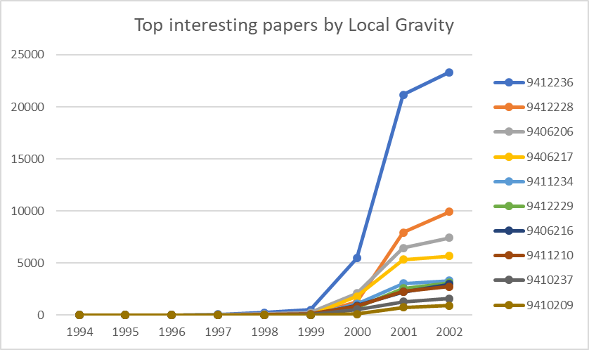
Figure 15. Top interesting papers from the Cit-HepTh dataset by Local Gravity model using original score values.

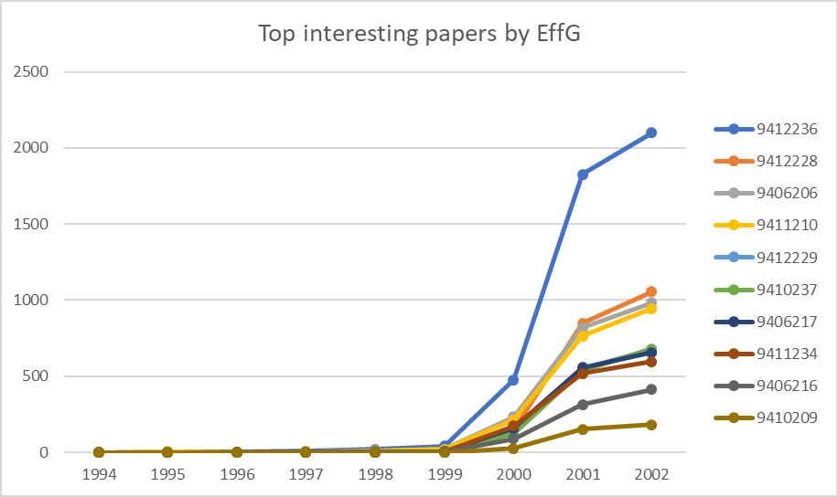
Figure 16. Top interesting papers from the Cit-HepTh dataset by Effective Distance Gravity model using original score values.

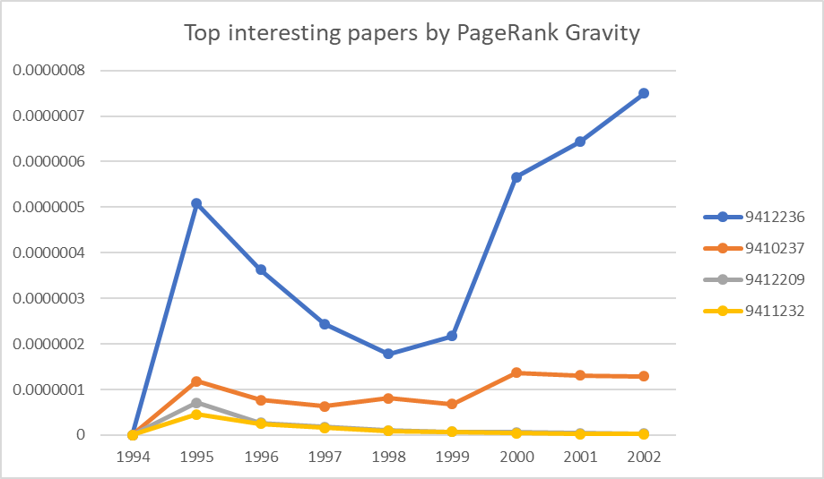
Figure 17. Top interesting papers from the Cit-HepTh dataset by PageRank Gravity model using original score values.

Two normalizations are considered in the research: Min-Max normalization and graph-size normalization.

Min-Max normalization transforms the scores to a common scale within the range [0, 1] by applying the formula:
$$G_{i}^{'}=\frac{G_{i}-min(G)}{max(G)-min(G)}$$
where $G_{i}$ is the original gravity score for paper i, $min(G)$ and $max(G)$ are the minimum and maximum scores of the papers across the year, respectively.

Alternatively, in graph-size normalization, each paper’s gravity score for a given year was divided by the total number of nodes (i.e., papers) present in the citation graph during that year:
$$G_{i}^{'}=\frac{G_{i}}{N_{y}}$$
where $G_{i}$ is the original gravity score for paper i, and $N_{y}$ is the total number of nodes (papers) in the graph for year y.
This approach ensures that the scores are adjusted for yearly graph size, allowing fair comparison between years with different numbers of papers.

Use of Min-Max vs. Graph-Size normalization for studying the influence dynamics

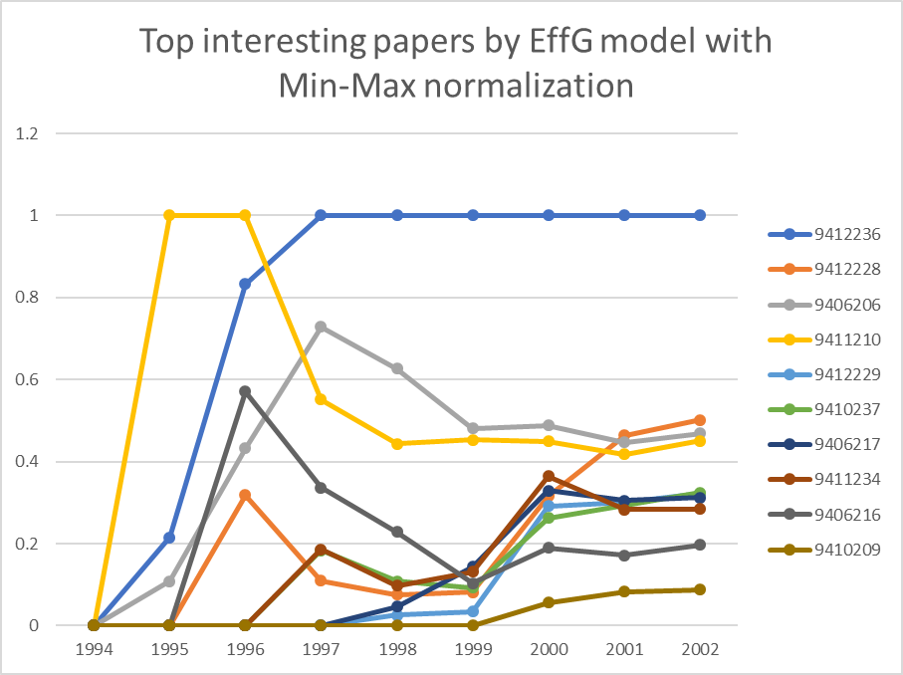  (a) | 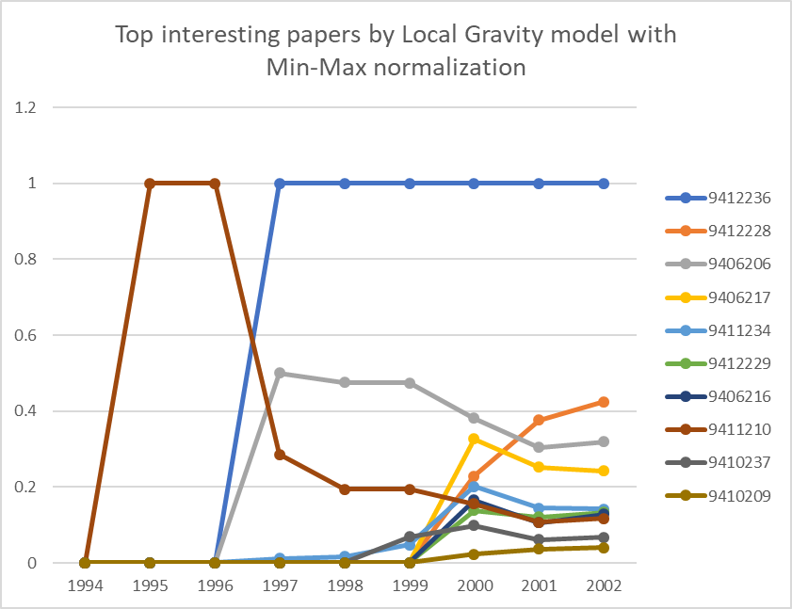  (b)
Figure 18. Top interesting papers from the Cit-HepTh dataset using Min-Max normalized score values by Effective Distance Gravity (a) and Local Gravity (b) models.

Figure 18 illustrates the influence of top papers, where the influence scores are normalized using Min-Max normalization. In this method, the highest score across all papers in a given year is scaled to 1, and the lowest to 0. While this allows easy identification of the most influential paper within each year, it introduces a limitation: if a paper consistently holds the highest score across multiple years, it will always receive a normalized score of 1, even if its influence continues to grow. As a result, Min-Max normalization may hide the dynamic growth of influence for dominant papers, making it impossible to tell whether their impact is stable or increasing over time.

For instance, on Figure 18, if the paper 9412236 has the highest score in 1997 and again in 1998, the Min-Max normalization assigns it a value of 1 for both years. Therefore, the detection is that this paper is the most influential in these years, but it is impossible to evaluate whether its influence has grown.

The graph-size normalization method helps to capture temporal dynamics better. This type of normalization adjusts the influence scores relative to the size of the network, allowing a fairer comparison across years.

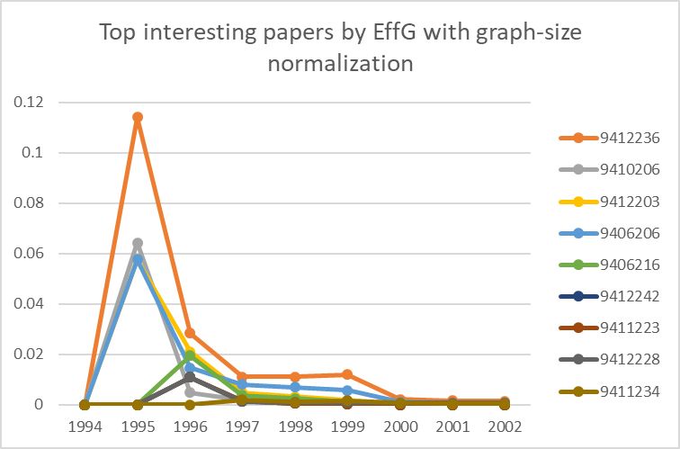  (a) | 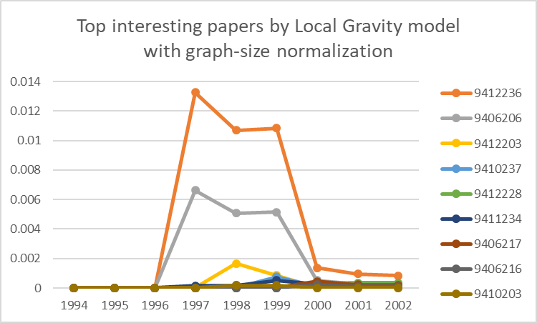  (b)
Figure 19. Top interesting papers from Cit-HepTh dataset using graph-size normalized scores values by Effective Distance Gravity (a) and Local Gravity (b) models.

For example, if a paper gets the same score two years in a row, but the number of papers in the network grows, the normalized score will go down. This means the paper’s influence has become smaller compared to the larger number of papers around it. On the other hand, if the paper keeps getting more citations as the network grows, its normalized score will go up. This shows that the paper is becoming more influential, even in a growing and more competitive research environment.

Thus, while min-max normalization highlights yearly top influencers, graph-size normalization offers a more nuanced view of how influence changes over time, making it more suitable for tracking dynamics in citation networks.

Insights from Local Gravity vs. Effective Distance Gravity models

Most papers have no measurable influence during the observed period, with their scores remaining at zero. This indicates that only a small number of papers have a lasting or visible impact. Such a pattern reflects a typical long-tail distribution [33] seen in citation networks, where a few papers receive most of the attention while the majority are rarely cited.

In addition, the sharp peaks on the plot indicate that a paper quickly gained significant attention but was later replaced or overshadowed as the field progressed.

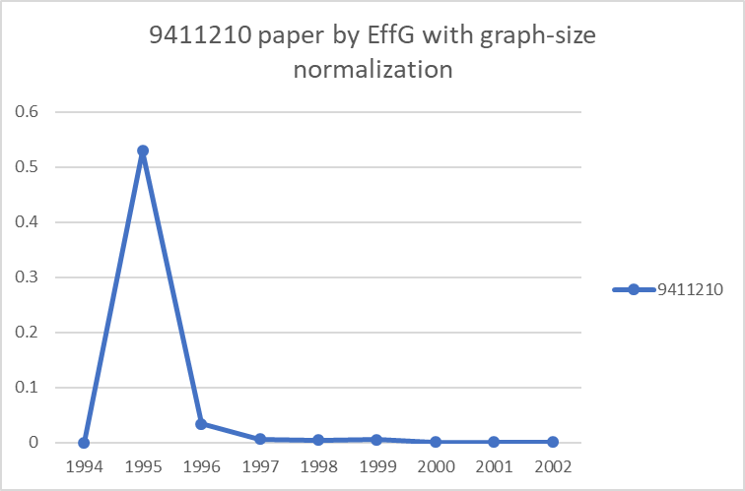  (a) | 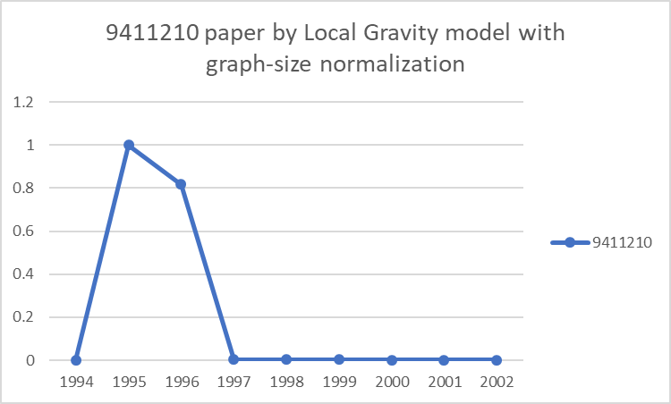  (b)
Figure 20. The example of the paper from the Cit-HepTh dataset using graph-size normalized scores values by Effective Distance Gravity (a) and Local Gravity (b) models.

One example of this is paper 9411210, by Cordes, Moore, and Ramgoolam, which focuses on 2D Yang–Mills theory and equivariant cohomology [34]. This paper has a dramatic spike in influence in 1995 (Figure 20) but experiences a rapid decline in later years. After closer examination of the paper’s history, the research shows that the paper was highly relevant during the 1994-1996 period, especially following the breakthroughs in 2D QCD dualities. It was widely read as an educational lecture series rather than a research article or formal review. After 1996, the field's interest shifted toward more advanced topics. By the early 2000s, this paper was no longer central to cutting-edge research, not because it lost value, but because the community moved on.

This case demonstrates that the gravity models can reliably detect papers that were highly influential in a specific window of time, even if their long-term impact diminished due to shifts in research focus.

In general, the results of the Local Gravity model and the Effective Distance Gravity model are very similar because both use the same mathematical structure to assign influence scores to papers. The main difference between them lies in how they calculate the distance between nodes in the citation network. Since the core scoring mechanism is similar, it is not surprising that both models often highlight similar influential papers. The small differences in the results come from the way each model defines and measures how far apart papers are in the network.

Insights from Local Gravity vs. PageRank vs. PageRank Gravity models

Year of interest: 1995
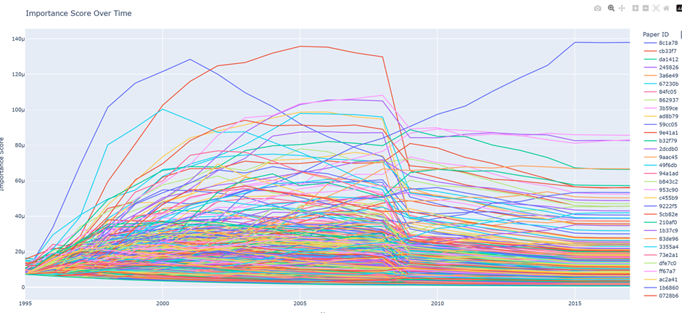
Figure 21. Top interesting papers from the DBLP dataset by PageRank model, 1995 year of interest.

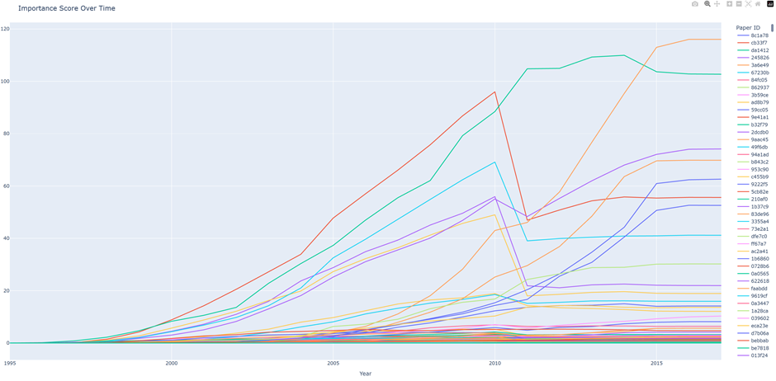
Figure 22. Top interesting papers from the DBLP dataset by PageRank Gravity model, 1995 year of interest.

The groups of most important papers according to the visual results of PageRank and PageRank Gravity have intersections, but there are also differences. The commonality is that in both models, there is a pattern of rising influence followed by a sudden drop, although the timing of the drop differs between them, which is particularly interesting.

The main difference is that the PageRank Gravity model clearly has more separation between the top ranks and the middle ranks. It is important to note that both results have the same number of papers. Many papers that might appear interesting when the PageRank score system is applied might get pushed to the bottom in the second model. This clear difference might make the PageRank Gravity model a better candidate for performing the task of separating the best papers. Another interesting phenomenon is the fact that in both models, there is a rise and then a fall of many papers’ influence, but the actual fall occurs at different times.

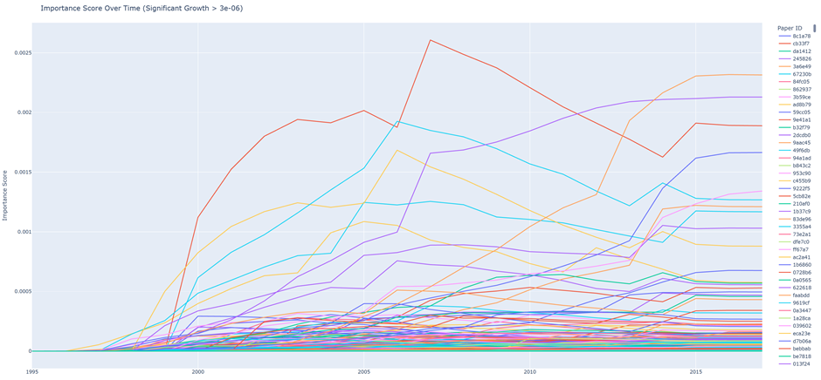
Figure 23. Top interesting papers from the DBLP dataset by Local Gravity model, 1995 year of interest.

The Local Gravity model agrees with the previous models in some of the papers to be the best, but there are differences. Like in the previous models, there is a rise in importance in most papers. Similar to the PageRank Gravity model, there is a clear separation between the best papers and all the others, although there are a few more papers that might be considered important in this model.

Unlike PageRank and PageRank Gravity models, the Local Gravity model shows much less of a clear trend when calculating influence scores. When focusing on the top-performing papers, some are rising, some are falling, and it always seems to change, like in real life. Also, both in PageRank and PageRank Gravity, there was always a noticeable rise followed by a fall, though they disagreed on the timing of that change. In contrast, the Local Gravity model does not show this scenario, which might indicate that PageRank-based models introduce some unnecessary calculations that lead to that result.

Year of interest: 1980

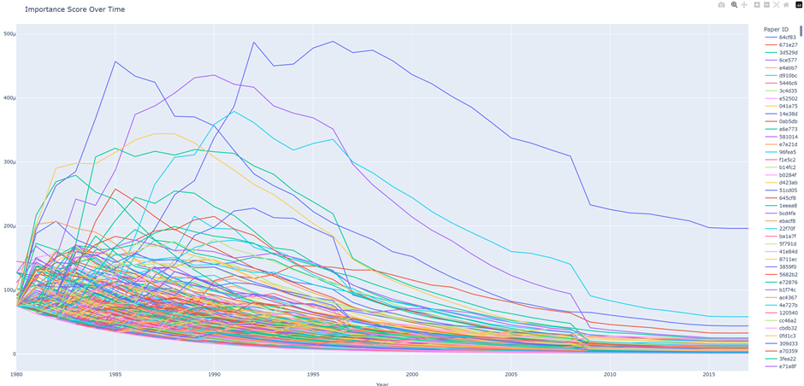
Figure 24. Top interesting papers from the DBLP dataset by PageRank model, 1980 year of interest.

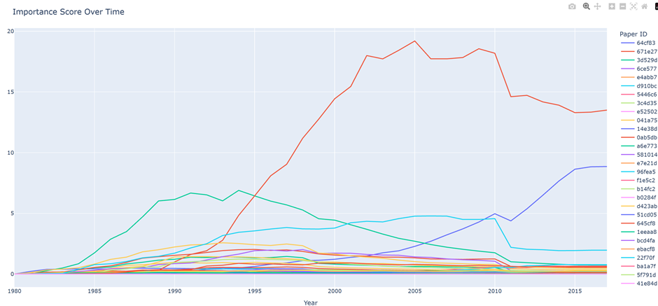
Figure 25. Top interesting papers from the DBLP dataset by PageRank Gravity model, 1980 year of interest.

The most important observation from the PageRank and PageRank Gravity models when analyzing papers from the year 1980 is that both models agree only on a very small group of papers.

In the PageRank model, most papers show a quick rise in influence followed by a steady decline. It might be inferred that no papers gain interest after a certain year. However, this is likely not true, and it contradicts the results of other models. This raises concerns about using standard PageRank (without Gravity) for this type of analysis. On the other hand, the PageRank Gravity model shows a more realistic picture—some papers continue to gain attention throughout the entire testing period. There is a clear separation between highly influential papers from the rest, and there is no similar trend shared by all papers as seen in PageRank.

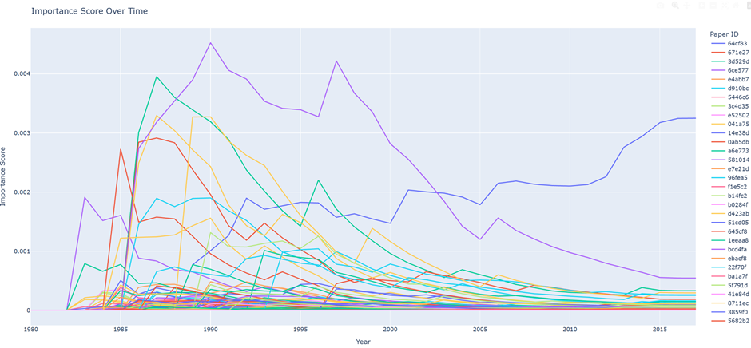
Figure 26. Top interesting papers from the DBLP dataset by Local Gravity model, 1980 year of interest.

There are some papers in which PageRank Gravity and Local Gravity models agree upon importance. Both have a very sharp rise at the beginning and an immediate fall, although at different times. On the other hand, the Local Gravity model has a paper that is rising while all fall. Also there are some spikes in scores while the general trend is falling.

Year of interest: 2000

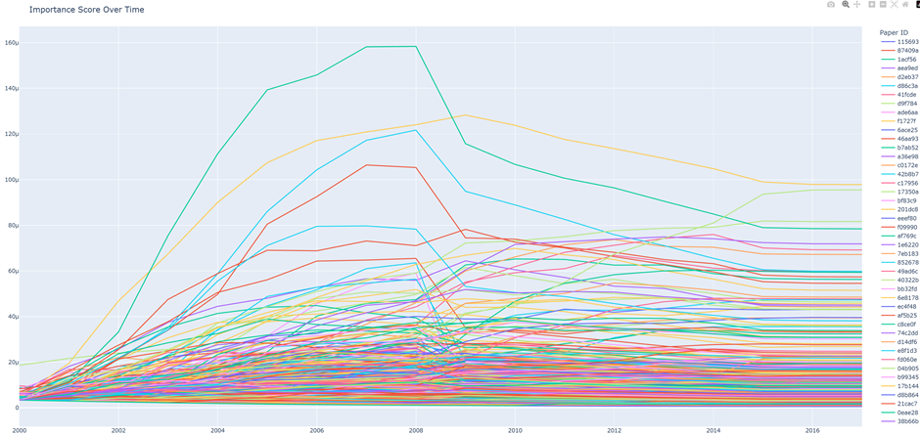
Figure 27. Top interesting papers from the DBLP dataset by PageRank model, 2000 year of interest.

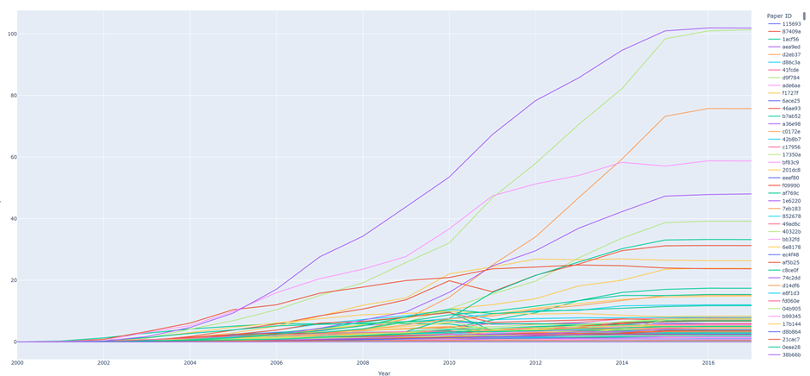
Figure 28. Top interesting papers from the DBLP dataset by PageRank Gravity model, 2000 year of interest.

First of all, both models have a small agreement on the best papers. PageRank scores have risen up until the same year in many papers and then have fallen for all the papers. On the other hand, PageRank Gravity scores have constantly risen. The separation between results is much clearer in the gravity model.

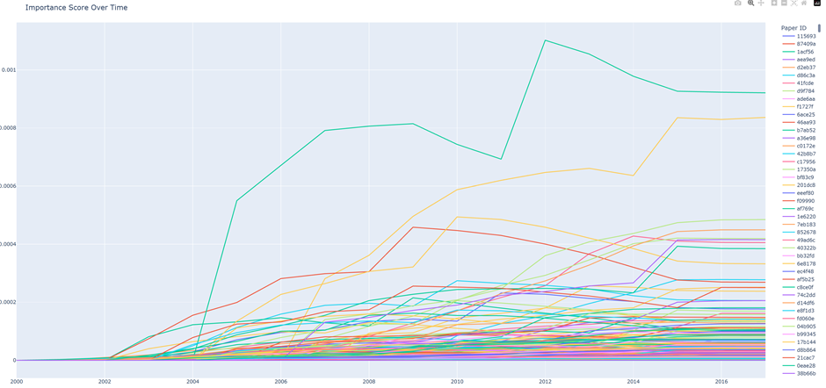
Figure 29. Top interesting papers from the DBLP dataset by Local Gravity model, 2000 year of interest.

There is a noticeable intersection between the top papers identified by the Local Gravity model and those highlighted by both the PageRank and PageRank Gravity models. Similar to PageRank Gravity, the influence scores in Local Gravity tend to increase over the years. Both models also show a clearer separation between the most successful papers and the rest.

Unlike PageRank Gravity, the Local Gravity model shows temporary drops in a paper’s influence over time, which is more likely to reflect real-world behavior. There is no consistent or noticeable trend among the most successful papers, making the results appear more realistic.

To sum up, the tested Gravity-based models clearly provided better separation between the most influential papers and those with medium or low influence. Even between closely related models like PageRank and PageRank Gravity, there were noticeable differences in identifying the top papers. This suggests that adding the gravity component has a significant impact on the results and may be used in citation networks.

Local Gravity, which relies mainly on node degree and distance between papers, produced results that were easier to interpret. In contrast, PageRank sometimes showed unrealistic behavior, such as sudden drops in influence across all papers or no increase in interest over time. These findings suggest that PageRank alone may be less suitable for measuring importance in citation networks compared to simpler models based on edge counts. In several cases, the results from PageRank Gravity seemed to better reflect real-world influence, which may be due more to the gravity component than to the PageRank element itself.

Nature of academic papers in citation network

During the research, a very important claim was raised about the nature of academic papers in a citation network - in a dataset large enough, throughout the years, most papers will form a large cluster together, and only a few will rise above the cluster and achieve high scores and sharp rise of their importance.

Gravity models were used to test the theory described above. First, a standard execution of PageRank Gravity was conducted for papers of the DPBL data set. Papers that were written in the year 2000 were chosen to be tracked.

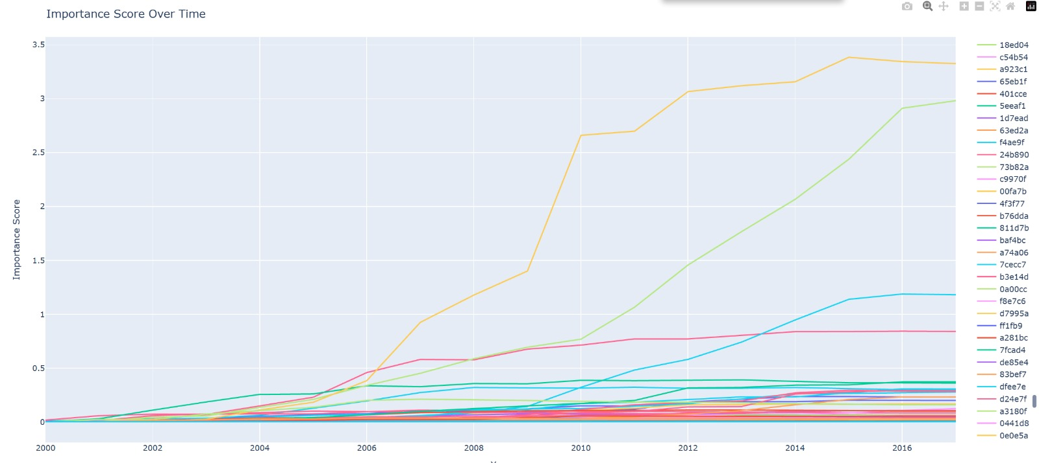
Figure 30. Top interesting papers from the DBLP dataset by PageRank Gravity model, 2000 year of interest.

Figure 30 displays the results; there are thousands of papers in that plot, and only a few rise above the cluster that was described. In order to show that this is a natural behavior of papers in such a dataset, and not only the behavior of the chosen subset, papers that were written in 2000, the few successful papers were removed from the dataset, and a second execution was made.

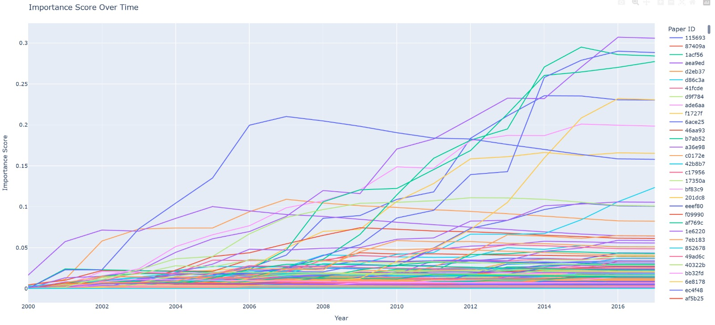
Figure 31. Top interesting papers from the DBLP dataset by PageRank Gravity model after excluding the first group of distinct papers, 2000 year of interest.

Figure 31 displays the result of the second execution, which did not include the most successful papers of the first execution. The results support the claim described at the beginning of the paragraph. To test this even further, another iteration was made.

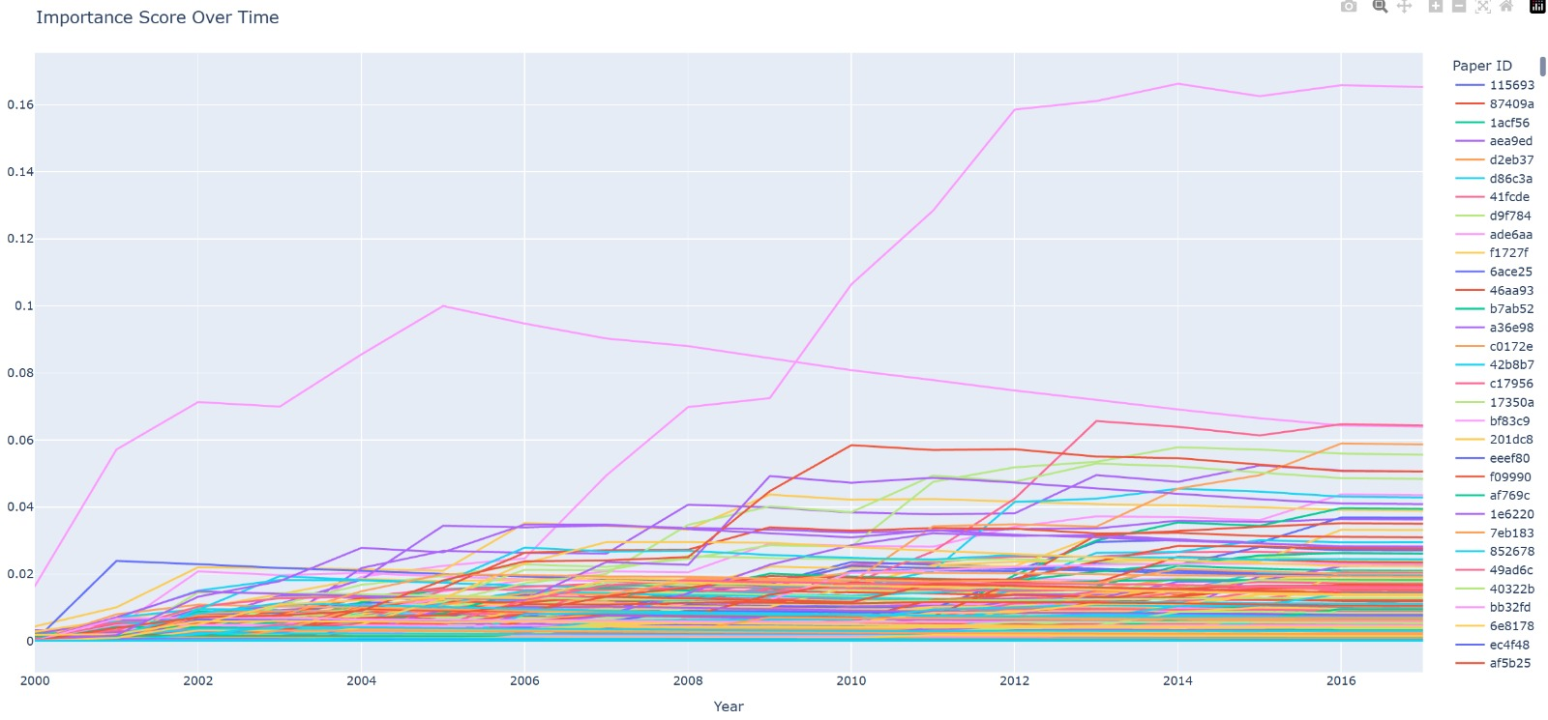
Figure 32. Top interesting papers from the DBLP dataset by PageRank Gravity model after excluding the second group of distinct papers, 2000 year of interest.

Figure 32 displays the result of the third iteration after removing the best papers of the second iteration. Again, the results support the claim that most papers, in this case thousands, are clustered together while a few papers rise above the cluster and have sharp influence changes.

User interface description

The GUI starts with the Parameters tab, where users can load a JSON file and configure settings for the analysis. This includes choosing the dataset, selecting the analysis model, and adjusting advanced options. The bottom “Run Engine” starts the analysis process.
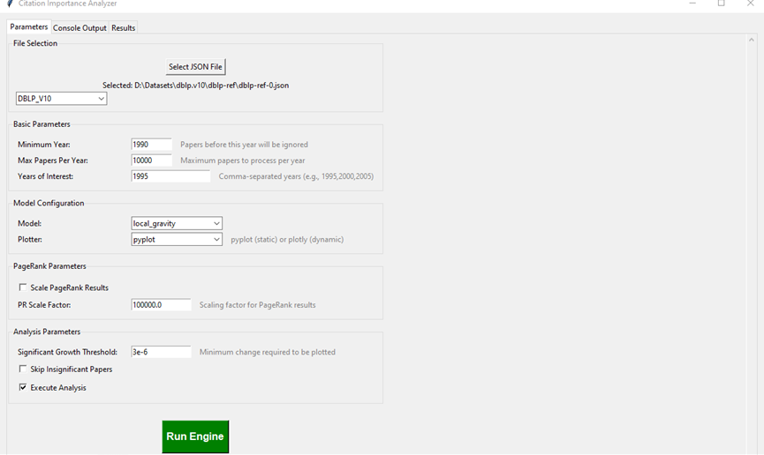
Figure 33. User interface screenshot: parameters tab

The console output tab provides live feedback during the analysis. It displays key metrics and confirms when results are saved and plots are generated, making it easy to track the progress and success of each run.
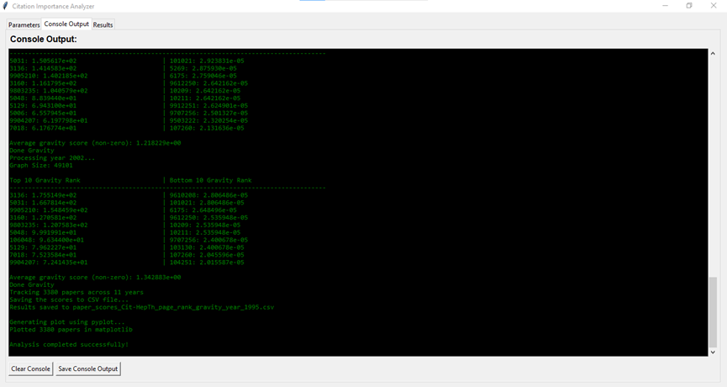
Figure 34. User interface screenshot: console output tab

The results tab displays the final visualization - a line chart showing how the importance scores of the selected papers change over time. Each colored line represents a paper, helping users to visualize the trends.

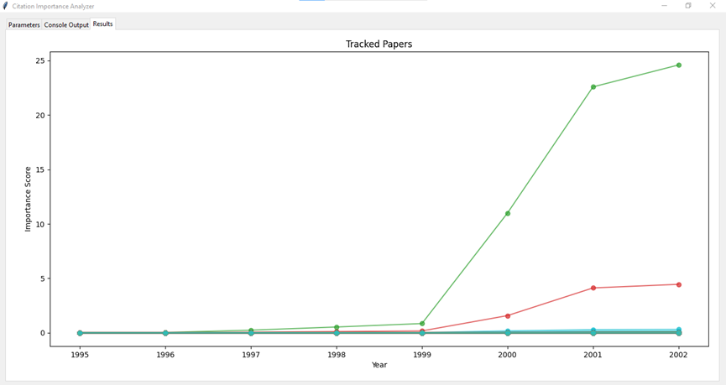
Figure 35. User interface screenshot: results tab

If the user selects Plotly in the parameters tab, a fully interactive version of this plot will open in the web browser, allowing for zooming and exploring data in a more detailed way.
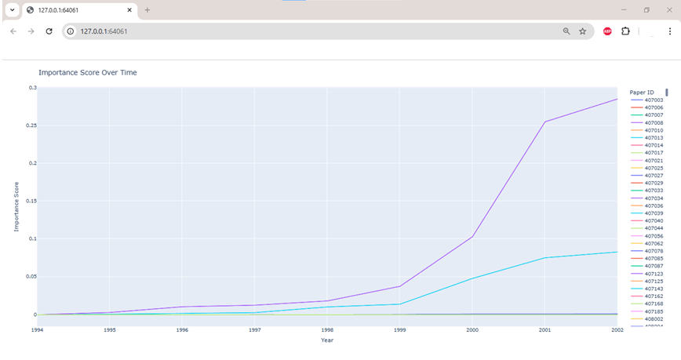
Figure 36. User interface screenshot: plotly view in web browser

User guide

  - Overview
The Citation Importance Analyzer is a GUI application designed to analyze citation networks and track the importance of academic papers over time. It supports multiple datasets and various importance calculation models, providing both numeric and graphic results.

  - Interface Overview

Parameters Tab Guide
There are three tabs in the application: Parameters, Console Output, and Results.
- Parameters Tab: Choose data set path, required params, and execute a run
- Console Output Tab: View logging information from the execution in real-time
- Results Tab: Display matplotlib visualizations (alternatively, plotly will start a browser with the results)

    - Parameters Tab

File Selection Section
Select JSON File Button
- Click to browse and select the dataset file
- Supported formats: JSON files containing citation data
- The selected file path will be displayed below the button
Dataset Dropdown
Choose from three supported datasets:
- DBLP_V10: DBLP academic database (default)
- Cit-HepTh: High Energy Physics Theory citations
- Cit-HepPh: High Energy Physics Phenomenology citations

Basic Parameters Section
Minimum Year (Default: 1990)
- Papers published before this year will be ignored
- Use this to focus on recent publications or reduce processing time
Max Papers Per Year (Default: 10,000)
- Maximum number of papers to process per year
- Helps control memory usage and processing time for large datasets
Years of Interest (Default: 1995)
- Comma-separated list of years to track (e.g., "1995,2000,2005")
- Papers from these years will be monitored throughout the analysis
- Although selecting multiple years is possible, we recommend choosing a single year for more focused analysis.

Model Configuration Section
Model Dropdown: Choose from seven importance calculation models:
- in_degree: score of node equals to in degree
- out_degree_centrality: score of node equals to out degree
- page_rank: Google's PageRank algorithm
- local_gravity: Local Gravity Model
- eigenvector_centrality: Eigenvector centrality Model
- page_rank_gravity: Combination of PageRank and gravity model
- effective_distance_gravity_model: Gravity model with modified distance element
Plotter Dropdown
- pyplot: Static matplotlib plots (displayed in Results tab)
- plotly: Interactive plots (opens in web browser)
PageRank Parameters Section
Scale PageRank Results (Checkbox)
- Enable scaling PageRank values (since PageRank is natively normalized)
PR Scale Factor (Default: 100,000)
- Multiplication factor for PageRank results
- Only applies when scaling is enabled

Analysis Parameters Section
Significant Growth Threshold (Default: 0.000003)
- Minimum average growth rate for a paper to be considered "significant"
- Papers below this threshold may be filtered from plots
- Calculation is based on the average derivative of the results
Skip Insignificant Papers (Checkbox)
- When enabled, only papers meeting the growth threshold are plotted
- Reduces visual clutter in results
Execute Analysis (Checkbox, Default: On)
- When enabled, it performs derivative analysis based on a significant growth threshold to identify growth patterns
- When disabled, all tracked papers are considered as “significant” by default, and generate basic plots
- Provides statistics about paper importance trends

    - Console Output Tab

Features
- Real-time Output: See analysis progress as it happens
- Clear Console: Remove all previous output
- Save Console Output: Export console text to a file

Typical Output Sequence
1. Parameter confirmation
2. Dataset loading progress
3. Year-by-year processing updates
4. Analysis statistics (if enabled)
5. CSV saving confirmation
6. Plotting confirmation
7. Completion message

Analysis Output Interpretation
When "Execute Analysis" is enabled, the console displays:
- Key Metrics
- Most rapidly growing paper: Paper that represents the highest growth rate at the end
- Most consistent riser: Paper that represents the highest average growth rate
- Paper with the biggest spike: Paper that represents the largest single-year increase
- Total papers tracked: Number of papers from years of interest
- Significant papers: Number of papers that exceed the growth threshold
- Percentage significant: Proportion showing meaningful growth
- Statistical Insights - these metrics help identify:
- Breakthrough papers gaining rapid recognition
- Consistently influential work
- Sudden recognition events
- Overall field growth patterns

    - Results Tab

Matplotlib Visualization
- X-axis: Years
- Y-axis: Importance scores
- Lines: Each tracked paper's importance over time
- Title: Indicates whether the growth threshold used

Understanding the Plots
- Rising lines: Papers gain importance over time
- Stable lines: Papers maintain consistent importance
- Declining lines: Papers lose relevance

  - Running the Analysis

Step-by-Step Process
- Configure Parameters
- Select your dataset file
- Choose an appropriate dataset type
- Set the year of interest
- Select the importance model
- Adjust thresholds as needed (we recommend not touching this in the first execution)
- Start Analysis
- Click the green "Run Engine" button
- The button will change to "Running..." and be disabled
- A progress bar will show that the analysis is active
- Monitor Progress
- Switch to the "Console Output" tab to see real-time progress
- Watch for status messages and any error reports
- View Results
- Results appear in the "Results" tab (for matplotlib)
- Plotly results open in your default web browser
- Console shows summary statistics
- Review the CSV file containing the influence scores (saved in the same directory as the program file)

  - Best Practices

Parameter Selection
- Start with default parameters for initial exploration
- Use higher growth thresholds to focus on the most significant papers
- Enable “Execute Analysis” and "Skip Insignificant Papers" for cleaner visualizations

Performance Optimization
- Process smaller year ranges first
- Use reasonable paper limits per year
- Consider the dataset size when setting parameters

Analysis Workflow
- Begin with basic parameters and small datasets (Cit-HepTh or Cit-HepPh)
- Examine console output for insights
- Adjust thresholds based on initial results
- Use both pyplot and plotly for different perspectives
- Save interesting console outputs for documentation

Maintenance guide

  - Overview

This maintenance guide provides essential information to ensure the support and future extension of the system after deployment. It is intended for developers, researchers, or technical staff who may need to perform updates, troubleshoot issues, adapt the system for new datasets, or implement additional models.

The Citation Network Analyzer is a Python-based application that analyzes citation networks using various centrality and influence models. The system consists of two main components:
- GUI Application: A Tkinter-based graphical user interface for parameter configuration and result visualization
- Influence Engine: The core computational module that performs citation network analysis

Key Features
- Multiple citation network analysis models (PageRank, Local Gravity, Eigenvector Centrality, etc.)
- Support for DBLP and CitHep datasets
- Interactive parameter configuration
- Real-time console output
- Results visualization using matplotlib and plotly
- Multi-threaded processing to prevent GUI freezing

  - System environment

Required software
- Operating system: Windows 10/11 or Linux
- Python version: 3.9 or higher
- Required Python packages: networkx, numpy, pandas, matplotlib, plotly, psutil
- Project Files: gui_app.py - The graphical user interface (GUI) module
- Influence_Engine.py - The core computation engine
- EffG_Model.py - Required for using the Effective Distance Gravity model
- JSON data files containing the citation datasets (DBLP, Cit-HepTh, Cit-HepPh)

Required hardware
- Standard personal computer
- At least 8 GB RAM (16 GB recommended for large datasets)
- Sufficient disk space (10 GB free space for datasets and results)
- Multi-core CPU processor recommended for better performance

  - System architecture

Component Structure
Citation Network Analyzer/
├── gui_app.py # Main GUI application
├── Influence_Engine.py # Core analysis engine
├── EffG_Model.py # External gravity model (dependency)
├── datasets/ # Dataset storage directory
│ ├── dblp-ref-0.json # DBLP dataset
│ └── cithep.json # CitHep dataset
└── results/ # Output directory
├── plots/
└── logs/

Key Classes and Components

CitationGUI (gui_app.py)
- Purpose: Main GUI controller and interface
- Key Methods:
o setup_ui(): Initialize GUI components
o run_engine_thread(): Execute analysis in a separate thread
o plot_with_matplotlib(): Display results in GUI
o get_current_params(): Extract user parameters

CitationNetworkAnalyzer (Influence_Engine.py)
- Purpose: Core analysis engine
- Key Methods:
o get_papers_dict_*(): Dataset loading methods
o calculate_importance(): Model execution
o local_gravity_model(): Custom gravity model implementation
o compute_gravity_rank(): PageRank-gravity hybrid model

  - Installation instructions

Setting up the environment

- Install Python version 3.9 or newer
- Install the required Python packages using the terminal or command prompt:
pip install networkx numpy pandas matplotlib plotly psutil
- Download all project files into a dedicated project directory on the computer
- Place the dataset files in an accessible location

  - Maintenance

    - Adding new models

The system is easily extensible by allowing the introduction of new centrality or gravity models by extending the CitationNetworkAnalyzer class located in the Influence_Engine.py module. This modular approach ensures flexibility and simplifies the process of incorporating additional algorithms or adapting existing ones to fit specific research needs.

Inside Influence_Engine.py in calculate_importance(self, model=None, graph=None), add a new elif statement and return the function that computes the scores. This function must return a dictionary {ID: Score}.

Moreover, if new models require additional parameters, the system supports extending the graphical user interface (GUI) by adding new input fields, enabling integration of model-specific configurations into the workflow.

    - Dataset format support

The system can be designed to support a wide range of citation datasets. In addition to the built-in preprocessing for several datasets, users will have the flexibility to integrate their own citation datasets by implementing custom preprocessing functions. This allows users to adapt the engine to work with any citation dataset format. Once the dataset is correctly preprocessed into the required structure, the influence engine can analyze it using the same core algorithms.

To add support for new dataset formats:
- Create parser method:
def get_papers_dict_new_format(self, file_path):
# Parse new format
return papers_by_year_dict
- Update loading logic in GUI and engine
- Add format option to GUI dropdown

  - Common error scenarios

Table 2. Common error scenarios
Issue | Possible cause | Solution
File not found | “Please select a valid JSON file”  Incorrect file path or missing dataset. | Verify that the dataset file exists and the path is correct.
Error reading dataset | “Error reading the dataset file”  “Unknown dataset”  The chosen dataset name does not correspond to the selected dataset file. | Choose the corresponding dataset name and file.
Could not read parameters | Some parameters are missing or have invalid types. | Complete all fields in the Parameters tab with valid values.
Input value error | One or more input parameters are invalid. The exact error details are displayed. | Correct the input based on the specific error provided.
No papers found for years [“year”] in the dataset. Available years: [“list of available years”] | Papers with inserted years of interest do not exist in the dataset. | Select years of interest from the list of available years in the dataset.
Error in saving CSV file | The CSV file is open. | Close the CSV file before running the engine.

  - Performance optimization

Memory optimization
- Batch processing: process datasets in chunks
- Garbage collection: implement explicit memory cleanup
- Data structures: use efficient data structures for large graphs

Processing speed
- Algorithm selection: choose appropriate models for the dataset size
- Parallel processing: implement multiprocessing for independent calculations
- Caching: cache intermediate results for repeated analyses

GUI responsiveness
- Thread management: ensure proper thread isolation
- Progress indicators: implement detailed progress reporting
- Lazy loading: load visualizations on demand

Optimization code examples:

# Memory optimization
import gc
def cleanup_memory():
gc.collect()

# Progress tracking
def update_progress(current, total):
progress_percentage = (current / total) * 100
self.progress['value'] = progress_percentage
self.root.update_idletasks()

  - Security considerations

File access security
- Valid file paths: prevent directory traversal attacks
- File permissions: ensure appropriate read/write permissions
- Input sanitization: validate user inputs

Data protection
- Sensitive data: handle citation data according to usage policies
- Local storage: secure temporary files and results
- User privacy: avoid logging sensitive information

Code security examples:

# Safe file path validation
import os
def validate_file_path(file_path):
if not os.path.exists(file_path):
raise ValueError("File does not exist")
if not file_path.endswith('.json'):
raise ValueError("Invalid file format")
return os.path.abspath(file_path)
  - Backup and Recovery

Data Backup Strategy
- Dataset backup: regular backup of the original datasets
- Configuration backup: save parameter configurations
- Results archive: periodic archival of analysis results
- Code versioning: maintain version history

Recovery Procedures
- System restore: restore from a known good configuration
- Data recovery: restore corrupted datasets from backup
- Partial recovery: recover specific analysis results
- Clean installation: complete system reinstallation process

Conclusion

This research was conducted to explore whether gravity centrality measurements provide interesting results when applied to citation networks, which are changing as time progresses. The goals of the research were:
- Create a system for testing different gravity models and multiple datasets of different scales.
- Check if the results match expectations: very similar behavior for most of the papers, while several papers should behave differently and rise above all the others.
- Check the nested perspective view of the results: after excluding the most influential papers, the rest of the papers still should have the same behavior in deeper reanalysis.

To support the investigation, we developed the Citation Importance Analyzer - a tool designed to run selected gravity models on citation networks to evaluate the importance of scientific papers throughout the years.

During the work on this project, we went on an exciting and learning journey into the world of citation networks. It required us to learn new terminology, evaluation techniques, and the underlying logic of the citation network. We examined a range of centrality measures and gravity-inspired models to identify the most appropriate ones for capturing the unique characteristics and dynamics of citation networks.

We successfully implemented a working program that fits the needs of our research. This system enables us to perform influence analysis on several citation networks with multiple gravitation models that are available for execution. The results of most models were as expected. After excluding the most influential papers, the results still had the same behavior in the nested view. During the process, we discovered at a late stage that the eigen-vector centrality-based models require a strongly connected graph to provide good results. Deeper research of this aspect during the first phase would have raised this issue sooner.

Throughout the entire research process, we had the support and guidance of our supervisors. Their pieces of advice were invaluable, especially as this is our first academic research work. They helped us understand how to structure, carry out, and validate research results correctly and effectively.

In summary, we successfully achieved all the objectives set for this project. Along the way, we faced various programming challenges but overcame them using our knowledge and skills gained during our studies. This research experience has been a perfect blend of applying our present knowledge and learning something new.

References

[1] NetworkX — NetworkX documentation. (n.d.). https://networkx.org/

[2] DiGraph—Directed graphs with self loops — NetworkX 3.4.2 documentation. (n.d.). https://networkx.org/documentation/stable/reference/classes/digraph.html

[3] adjacency_matrix — NetworkX 3.4.2 documentation. (n.d.). https://networkx.org/documentation/stable/reference/generated/networkx.linalg.graphmatrix.adjacency_matrix.html

[4] all_pairs_shortest_path_length — NetworkX 3.4.2 documentation. (n.d.). https://networkx.org/documentation/stable/reference/algorithms/generated/networkx.algorithms.shortest_paths.unweighted.all_pairs_shortest_path_length.html

[5] Matplotlib — Visualization with Python. (n.d.). https://matplotlib.org/

[6] Data apps for production | Plotly. (n.d.). Plotly. https://plotly.com/

[7] tkinter — Python interface to Tcl/Tk. (n.d.). Python Documentation. https://docs.python.org/3/library/tkinter.html

[8] AMiner, social@aminer.org. (n.d.). AMiner. https://www.aminer.cn/citation

[9] SNAP: Network datasets: High-energy physics Phenomenology citation network. (n.d.). https://snap.stanford.edu/data/cit-HepPh.html

[10] SNAP: Network datasets: High-energy physics theory citation network. (n.d.). https://snap.stanford.edu/data/cit-HepTh.html

[11] Page, L., Brin, S., Motwani, R., & Winograd, T. (1999). The PageRank citation ranking: Bringing order to the web. Stanford infolab.

[12] Sparse arrays (scipy.sparse) — SciPy v1.15.3 Manual. (n.d.). https://docs.scipy.org/doc/scipy/reference/sparse.html

[13] single_source_shortest_path_length — NetworkX 3.5 documentation. (n.d.). https://networkx.org/documentation/stable/reference/algorithms/generated/networkx.algorithms.shortest_paths.unweighted.single_source_shortest_path_length.html

[14] pagerank — NetworkX 3.5 documentation. (n.d.). https://networkx.org/documentation/stable/reference/algorithms/generated/networkx.algorithms.link_analysis.pagerank_alg.pagerank.html

[15] Introduction to Social Media Investigation Jennifer Golbeck, 2015, 978-0-12-801656-5

[16] Duanbing Chen, Linyuan Lü, Ming-Sheng Shang, Yi-Cheng Zhang, Tao Zhou, Identifying influential nodes in complex networks, Physica A: Statistical mechanics and its applications 391 (4) (2012) 1777–1787.

[17] Data Viz | Jacob Jameson. (n.d.).
https://jacobjameson.com/ppha-30560/Final%20Project/

[18] Mark EJ Newman, A measure of betweenness centrality based on random walks, Social networks 27 (1) (2005) 39–54.

[19] Phillip Bonacich, Paulette Lloyd, Eigenvector-like measures of centrality for asymmetric relations, Social networks 23 (3) (2001) 191–201.

[20] L. Fei, Q. Zhang, Y. Deng, Identifying influential nodes in complex networks based on the inverse-square law, Physica A: Statistical Mechanics and its Applications 512 (2018) 1044–1059.

[21] L. Fei, Q. Zhang, Y. Deng, Identifying influential nodes in complex networks based on the inverse-square law, Physica A: Statistical Mechanics and its Applications 512 (2018) 1044–1059.

[22] Z. Li, T. Ren, X. Ma, S. Liu, Y. Zhang, T. Zhou, Identifying influential spreaders by gravity model, Scientific reports 9 (1) (2019) 1–7.

[23] H. Li, Q. Shang, Y. Deng, A generalized gravity model for influential spreaders identification in complex networks, Chaos, Solitons & Fractals 143 (2021),

[24] Na Zhao, Qian Liu, Hao Wang, Shenglong Yang, Pingzhou Li, Jian Wang, Estimating the relative importance of nodes in complex networks based on network embedding and gravity model, Journal of King Saud University - Computer and Information Sciences, Volume 35, Issue 9,2023,101758,ISSN 1319-1578,

[25] Zhao, J., Wen, T., Jahanshahi, H., & Cheong, K. H. (2022). The random walk-based gravity model to identify influential nodes in complex networks. Information Sciences, 609, 1706-1720.

[26] Dirk Brockmann, Dirk Helbing, The hidden geometry of complex, network-driven contagion phenomena, science 342 (6164) (2013) 1337–1342.

[27] Qiuyan Shang, Yong Deng, Kang Hao Cheong, Identifying influential nodes in complex networks: Effective distance gravity model,Information Sciences,Volume 577,2021, Pages 162-179, ISSN 0020-0255,

[28] F. Liu, Z. Wang, Y. Deng, Gmm: A generalized mechanics model for identifying the importance of nodes in complex networks, Knowledge-Based
Systems 193 (105464) (2020) 10.1016/j.knosys.2019.105464.

[29] Fan, W., He, Y., Han, X. et al. A new model to identify node importance in complex networks based on DEMATEL method. Sci Rep 11, 22829 (2021). https://doi.org/10.1038/s41598-021-02306-y

[30] Radu, R. T. R. (n.d.). PageRank Algorithm - The Mathematics of Google Search. https://pi.math.cornell.edu/~mec/Winter2009/RalucaRemus/Lecture3/lecture3.html

[31] Yahoo | Mail, Weather, Search, politics, news, finance, sports & videos. (n.d.-b). Yahoo! https://www.yahoo.com/

[32] Random Surfer model explained & best practices - Ryte Wiki. (n.d.). https://en.ryte.com/wiki/Random_Surfer_Model/

[33] Anderson, Chris. The Long Tail: Why the Future of Business Is Selling Less of More. Hachette Books, 11 July 2006.

[34] Cordes, S., Moore, G., & Ramgoolam, S. (1995). Lectures on 2D Yang-Mills theory, equivariant cohomology and topological field theories. Nuclear Physics B-Proceedings Supplements, 41(1-3), 184-244.

Appendix: program code

  - gui_app.py

import tkinter as tk
import traceback
from tkinter import filedialog, messagebox, scrolledtext
from tkinter import ttk
import threading
from contextlib import redirect_stdout, redirect_stderr
from matplotlib.backends.backend_tkagg import FigureCanvasTkAgg
import matplotlib.pyplot as plt
from Influence_Engine import *
import queue
import os
import pandas as pd
from collections import defaultdict
import numpy as np
from datetime import datetime

# Class for redirecting console output to the GUI text widget (used to capture stdout/stderr)
class ConsoleRedirect:
"""Redirects stdout/stderr to the GUI console"""

def __init__(self, text_widget, root):
self.text_widget = text_widget
self.root = root

def write(self, string):
# Schedule GUI update on main thread
self.root.after(0, self._write_to_console, string)

def _write_to_console(self, string):
self.text_widget.insert(tk.END, string)
self.text_widget.see(tk.END)
self.text_widget.update_idletasks()

def flush(self):
pass

# Main GUI Class
class CitationGUI:
def __init__(self, root):
self.engine = None
self.root = root
self.root.title("Citation Importance Analyzer")
self.root.geometry("1200x800")

# Initialize parameters with defaults from Influence_Engine
self.file_path = r'D:\Datasets\dblp.v10\dblp-ref\dblp-ref-0.json'
self.min_year = tk.IntVar(value=1990)
self.max_papers_per_year = tk.IntVar(value=10000)
self.years_of_interest = tk.StringVar(value="1995")
self.plotter_var = tk.StringVar(value="pyplot")
self.model_var = tk.StringVar(value="local_gravity")
self.scale_pr = tk.BooleanVar(value=False)
self.pr_scale_factor = tk.DoubleVar(value=1e5)
self.significant_growth_threshold = tk.DoubleVar(value=3e-06)
self.skip_insignificant = tk.BooleanVar(value=False)
self.execute_analysis = tk.BooleanVar(value=True)
self.dataset = tk.StringVar(value="DBLP_V10")

# Thread-safe queue for communication from worker thread back to GUI
self.result_queue = queue.Queue()
self.is_running = False

# Build the full GUI
self.setup_ui()

# Handle window closing properly
self.root.protocol("WM_DELETE_WINDOW", self.on_closing)

def on_closing(self):
"""Handle application closing"""
if self.is_running:
if messagebox.askokcancel("Quit", "Analysis is running. Do you want to quit?"):
self.is_running = False
self.root.quit()
self.root.destroy()
else:
self.root.quit()
self.root.destroy()

def setup_ui(self):
"""Create the main UI with tabs"""
# Create main frame with scrollable content
main_frame = tk.Frame(self.root)
main_frame.pack(fill=tk.BOTH, expand=True, padx=10, pady=10)

# Create notebook for tabs
notebook = ttk.Notebook(main_frame)
notebook.pack(fill=tk.BOTH, expand=True)

# Parameters tab
params_frame = ttk.Frame(notebook)
notebook.add(params_frame, text="Parameters")

# Console tab
console_frame = ttk.Frame(notebook)
notebook.add(console_frame, text="Console Output")

# Results tab
results_frame = ttk.Frame(notebook)
notebook.add(results_frame, text="Results")

self.setup_parameters_tab(params_frame)
self.setup_console_tab(console_frame)
self.setup_results_tab(results_frame)

def setup_parameters_tab(self, parent):
"""Set up the full parameters tab"""
# Create scrollable frame for parameters
canvas = tk.Canvas(parent)
scrollbar = ttk.Scrollbar(parent, orient="vertical", command=canvas.yview)
scrollable_frame = ttk.Frame(canvas)

scrollable_frame.bind(
"<Configure>",
lambda e: canvas.configure(scrollregion=canvas.bbox("all"))
)

canvas.create_window((0, 0), window=scrollable_frame, anchor="nw")
canvas.configure(yscrollcommand=scrollbar.set)

# File selection section
file_section = ttk.LabelFrame(scrollable_frame, text="File Selection", padding="10")
file_section.pack(fill=tk.X, pady=5)

tk.Button(file_section, text="Select JSON File", command=self.select_file).pack(pady=5)
self.file_label = tk.Label(file_section, text=f"Selected: {self.file_path}", wraplength=600)
self.file_label.pack()

data_sets = ["DBLP_V10", "Cit-HepTh", "Cit-HepPh"]
self.dataset_combo = ttk.Combobox(file_section, values=data_sets, textvariable=self.dataset, width=20)
self.dataset_combo.pack(side=tk.LEFT)

# Basic parameters section
basic_section = ttk.LabelFrame(scrollable_frame, text="Basic Parameters", padding="10")
basic_section.pack(fill=tk.X, pady=5)

# Min Year
min_year_frame = tk.Frame(basic_section)
min_year_frame.pack(fill=tk.X, pady=2)
tk.Label(min_year_frame, text="Minimum Year:", width=25, anchor='w').pack(side=tk.LEFT)
tk.Entry(min_year_frame, textvariable=self.min_year, width=10).pack(side=tk.LEFT)
tk.Label(min_year_frame, text="Papers before this year will be ignored", fg="gray").pack(side=tk.LEFT,
padx=(10, 0))

# Max Papers Per Year
max_papers_frame = tk.Frame(basic_section)
max_papers_frame.pack(fill=tk.X, pady=2)
tk.Label(max_papers_frame, text="Max Papers Per Year:", width=25, anchor='w').pack(side=tk.LEFT)
tk.Entry(max_papers_frame, textvariable=self.max_papers_per_year, width=10).pack(side=tk.LEFT)
tk.Label(max_papers_frame, text="Maximum papers to process per year", fg="gray").pack(side=tk.LEFT,
padx=(10, 0))

# Years of Interest
years_frame = tk.Frame(basic_section)
years_frame.pack(fill=tk.X, pady=2)
tk.Label(years_frame, text="Years of Interest:", width=25, anchor='w').pack(side=tk.LEFT)
tk.Entry(years_frame, textvariable=self.years_of_interest, width=20).pack(side=tk.LEFT)
tk.Label(years_frame, text="Comma-separated years (e.g., 1995,2000,2005)", fg="gray").pack(side=tk.LEFT,
padx=(10, 0))

# Model Selection
model_section = ttk.LabelFrame(scrollable_frame, text="Model Configuration", padding="10")
model_section.pack(fill=tk.X, pady=5)

model_frame = tk.Frame(model_section)
model_frame.pack(fill=tk.X, pady=2)
tk.Label(model_frame, text="Model:", width=25, anchor='w').pack(side=tk.LEFT)
models = [
"in_degree", "out_degree_centrality", "page_rank",
"local_gravity", "eigenvector_centrality", "page_rank_gravity", "effective_distance_gravity_model"
]

self.model_combo = ttk.Combobox(model_frame, values=models, textvariable=self.model_var, width=20)
self.model_combo.pack(side=tk.LEFT)

# Plotter Selection
plotter_frame = tk.Frame(model_section)
plotter_frame.pack(fill=tk.X, pady=2)
tk.Label(plotter_frame, text="Plotter:", width=25, anchor='w').pack(side=tk.LEFT)
plotter_combo = ttk.Combobox(plotter_frame, values=["pyplot", "plotly"], textvariable=self.plotter_var,
width=20)
plotter_combo.pack(side=tk.LEFT)
tk.Label(plotter_frame, text="pyplot (static) or plotly (dynamic)", fg="gray").pack(side=tk.LEFT, padx=(10, 0))

# PageRank specific parameters
pr_section = ttk.LabelFrame(scrollable_frame, text="PageRank Parameters", padding="10")
pr_section.pack(fill=tk.X, pady=5)

scale_pr_frame = tk.Frame(pr_section)
scale_pr_frame.pack(fill=tk.X, pady=2)
tk.Checkbutton(scale_pr_frame, text="Scale PageRank Results", variable=self.scale_pr).pack(side=tk.LEFT)

pr_scale_frame = tk.Frame(pr_section)
pr_scale_frame.pack(fill=tk.X, pady=2)
tk.Label(pr_scale_frame, text="PR Scale Factor:", width=25, anchor='w').pack(side=tk.LEFT)
tk.Entry(pr_scale_frame, textvariable=self.pr_scale_factor, width=15).pack(side=tk.LEFT)
tk.Label(pr_scale_frame, text="Scaling factor for PageRank results", fg="gray").pack(side=tk.LEFT, padx=(10, 0))

# Analysis parameters
analysis_section = ttk.LabelFrame(scrollable_frame, text="Analysis Parameters", padding="10")
analysis_section.pack(fill=tk.X, pady=5)

threshold_frame = tk.Frame(analysis_section)
threshold_frame.pack(fill=tk.X, pady=2)
tk.Label(threshold_frame, text="Significant Growth Threshold:", width=25, anchor='w').pack(side=tk.LEFT)
tk.Entry(threshold_frame, textvariable=self.significant_growth_threshold, width=15).pack(side=tk.LEFT)
tk.Label(threshold_frame, text="Minimum change required to be plotted", fg="gray").pack(side=tk.LEFT,
padx=(10, 0))

skip_frame = tk.Frame(analysis_section)
skip_frame.pack(fill=tk.X, pady=2)
tk.Checkbutton(skip_frame, text="Skip Insignificant Papers", variable=self.skip_insignificant).pack(
side=tk.LEFT)

execute_frame = tk.Frame(analysis_section)
execute_frame.pack(fill=tk.X, pady=2)
tk.Checkbutton(execute_frame, text="Execute Analysis", variable=self.execute_analysis).pack(side=tk.LEFT)

# Run button
run_frame = tk.Frame(scrollable_frame)
run_frame.pack(fill=tk.X, pady=20)
self.run_button = tk.Button(run_frame, text="Run Engine", command=self.run_engine_thread,
bg="green", fg="white", font=("Arial", 12, "bold"), height=2)
self.run_button.pack()

self.progress = ttk.Progressbar(run_frame, mode='indeterminate')
self.progress.pack(fill=tk.X, pady=5)

canvas.pack(side="left", fill="both", expand=True)
scrollbar.pack(side="right", fill="y")

def setup_console_tab(self, parent):
"""Set up console output tab"""
# Console output
console_frame = tk.Frame(parent)
console_frame.pack(fill=tk.BOTH, expand=True, padx=5, pady=5)

tk.Label(console_frame, text="Console Output:", font=("Arial", 12, "bold")).pack(anchor='w')

self.console_text = scrolledtext.ScrolledText(console_frame, wrap=tk.WORD,
font=("Consolas", 9), bg="black", fg="green")
self.console_text.pack(fill=tk.BOTH, expand=True, pady=5)

# Clear console button
clear_frame = tk.Frame(console_frame)
clear_frame.pack(fill=tk.X, pady=5)
tk.Button(clear_frame, text="Clear Console", command=self.clear_console).pack(side=tk.LEFT)
tk.Button(clear_frame, text="Save Console Output", command=self.save_console).pack(side=tk.LEFT, padx=5)

def setup_results_tab(self, parent):
"""Set up results tab"""
# Results visualization
self.fig, self.ax = plt.subplots(figsize=(10, 6))
self.canvas = FigureCanvasTkAgg(self.fig, master=parent)
self.canvas.get_tk_widget().pack(fill=tk.BOTH, expand=True)

def select_file(self):
"""Open a file dialog to select the JSON file; update the file path"""
path = filedialog.askopenfilename(filetypes=[("JSON files", "*.json")])
if path:
self.file_path = path
self.file_label.config(text=f"Selected: {self.file_path}")

def clear_console(self):
"""Clear the console output in the console tab"""
self.console_text.delete(1.0, tk.END)

def save_console(self):
"""Save the console output into a text file"""
content = self.console_text.get(1.0, tk.END)
if content.strip():
filename = filedialog.asksaveasfilename(
defaultextension=".txt",
filetypes=[("Text files", "*.txt"), ("All files", "*.*")]
)
if filename:
with open(filename, 'w') as f:
f.write(content)
messagebox.showinfo("Success", "Console output saved successfully!")

def get_current_params(self):
"""Get current parameter values from the GUI input fields safely"""
try:
return {
'file_path': self.file_path,
'min_year': self.min_year.get(),
'max_papers_per_year': self.max_papers_per_year.get(),
'years_of_interest': set(map(int, self.years_of_interest.get().strip().split(','))),
'plotter': self.plotter_var.get(),
'model': self.model_var.get(),
'scale_pr': self.scale_pr.get(),
'pr_scale_factor': self.pr_scale_factor.get(),
'significant_growth_threshold': self.significant_growth_threshold.get(),
'skip_insignificant': self.skip_insignificant.get(),
'execute_analysis': self.execute_analysis.get(),
'dataset': self.dataset.get()
}
except tk.TclError:
return None

def validate_params(self, params):
"""
Validate the parameters before running analysis.
Raises ValueError if invalid.
"""

if params['min_year'] < 0:
raise ValueError("Minimum year cannot be negative.")

if params['min_year'] > datetime.now().year or params['min_year'] < 1600:
raise ValueError("Min year seems unrealistic. Please check your input.")

if params['max_papers_per_year'] <= 0:
raise ValueError("Max papers per year must be a positive integer.")

if params['pr_scale_factor'] < 0:
raise ValueError("PR scale factor cannot be negative.")

if params['significant_growth_threshold'] < 0:
raise ValueError("Significant growth threshold cannot be negative.")

def run_engine_thread(self):
"""Run engine in a separate thread to prevent GUI freezing"""
if self.is_running:
return # Prevent multiple runs simultaneously

# Get parameters safely on main thread
params = self.get_current_params()
if params is None:
messagebox.showerror ("Error", "Could not read parameters")
return

# Perform user inputs validation
try:
self.validate_params(params)
except Exception as e:
messagebox.showerror("Input Error", f"{e}")
return

self.is_running = True
self.run_button.config(state='disabled', text='Running...')
self.progress.start()
self.clear_console()

# Create console redirect
console_redirect = ConsoleRedirect(self.console_text, self.root)

def run_analysis():
"""Run the actual engine logic inside the thread"""
try:
# start engine with params
self.engine = CitationNetworkAnalyzer(
min_year=params['min_year'],
max_papers_per_year=params['max_papers_per_year'],
years_of_interest=params['years_of_interest'],
plotter=params['plotter'],
file_path=params['file_path'],
model_to_execute=params['model'],
scale_pr=params['scale_pr'],
pr_scale_factor=params['pr_scale_factor'],
significant_growth_threshold=params['significant_growth_threshold'],
skip_insignificant=params['skip_insignificant'],
execute_analysis=params['execute_analysis'],
dataset=params['dataset']
)

# Redirect stdout and stderr to console
with redirect_stdout(console_redirect), redirect_stderr(console_redirect):
print("Starting analysis...")
print(f"Parameters:")
print(f" File: {params['file_path']}")
print(f" Min Year: {params['min_year']}")
print(f" Max Papers/Year: {params['max_papers_per_year']}")
print(f" Years of Interest: {params['years_of_interest']}")
print(f" Model: {params['model']}")
print(f" Plotter: {params['plotter']}")
print("-" * 50)

result = self.run_influence_engine(params)

# Send result back to main thread
self.result_queue.put(('success', result))
print("\nAnalysis completed successfully!")

except Exception as e:
error_msg = f"Error occurred: {str(e)}\n\nTraceback:\n{traceback.format_exc()}"
print(error_msg)
self.result_queue.put(('error', error_msg))
finally:
# Schedule cleanup on main thread
self.root.after(0, self.analysis_finished)

# Start analysis in separate thread
thread = threading.Thread(target=run_analysis, daemon=True)
thread.start()

def analysis_finished(self):
"""Called when analysis is finished. Reset the GUI state and handle any results or errors"""
self.is_running = False
self.run_button.config(state='normal', text='Run Engine')
self.progress.stop()

# Check for results
try:
while not self.result_queue.empty():
result_type, result_data = self.result_queue.get_nowait()
if result_type == 'error':
messagebox.showerror("Error", f"Analysis failed: {result_data}")
elif result_type == 'success':
# Handle successful result if needed
pass
except queue.Empty:
pass

def run_influence_engine(self, params):
"""
Performs the main workflow:
- loads data from selected dataset
- constructs citation graph year by year
- calculates importance scores per paper
- saves the results to CSV
- optionally analyzes growth trends
- generates plots
"""

# Unpack parameters from GUI input
file_path = params['file_path']
dataset = params['dataset']
model = params['model']
plotter = params['plotter']
years_of_interest = params['years_of_interest']
execute_analysis = params['execute_analysis']
significant_growth_threshold = params['significant_growth_threshold']

# Validate file path
if not file_path or not os.path.exists(file_path):
raise Exception("Please select a valid JSON file")

print("Loading papers from dataset...")

# Load papers dictionary depending on selected dataset
if dataset == "Cit-HepTh" or dataset == "Cit-HepPh":
papers_dict = self.engine.get_papers_dict_cithep_dataset(file_path)
elif dataset == "DBLP_V10":
papers_dict = self.engine.get_papers_dict_dblp_dataset(file_path)
else:
raise Exception(f"Unknown dataset: {dataset}")

print("Initializing graph...")
g = self.engine.init_graph() # initialize empty graph
tracked_papers = defaultdict(list) # papers to track importance scores
tracked_years = [] # save tracked years for score saving
years_read_from_ds = [] # list of years available in dataset

# Validate years of interest
available_years = set(papers_dict.keys())
years_of_interest_available = available_years.intersection(years_of_interest)

if not years_of_interest_available:
raise Exception(
f"No papers found for years {sorted(years_of_interest)} in the dataset. "
f"Available years: {sorted(available_years)}")

print(f"Found papers for years of interest: {sorted(years_of_interest_available)}")

# Calculate scores for all years
for year in sorted(papers_dict.keys()):
print(f"Processing year {year}...")
papers_of_year = papers_dict[year]
self.engine.add_papers_of_year(graph= g,papers= papers_of_year)
scores = self.engine.calculate_importance(model=model, graph=g)

# Start tracking new papers that appeared in years of interest
if year in years_of_interest:
for paper in papers_of_year:
tracked_papers[paper['id']] = []

# Save year for tracked papers
if year >= sorted(years_of_interest)[0]:
tracked_years.append(year)

# Save scores for tracked papers
for paper_id in tracked_papers:
tracked_papers[paper_id].append(scores.get(paper_id, 0))

years_read_from_ds.append(year)
print(f"Tracking {len(tracked_papers)} papers across {len(years_read_from_ds)} years")

# Convert the scores to DataFrame and save to csv
print("Saving the scores to CSV file...")
try:
if tracked_papers:
# Create columns names: paperID + year columns
columns = ['paperID'] + [f'{year}' for year in tracked_years]

# Prepare data for DataFrame
data = []
for paper_id, scores in tracked_papers.items():
row = [paper_id] + scores
data.append(row)

# Create DataFrame
df = pd.DataFrame(data, columns = columns)

#Save to csv
output_filename = f"paper_scores_{self.dataset.get()}_{self.model_var.get()}_year_{self.years_of_interest.get()}.csv"
df.to_csv(output_filename, index=False)
print(f"Results saved to {output_filename}")
else:
print("No papers were tracked - CSV not created")
except Exception:
raise Exception("Error in saving CSV file")

# Analysis section
if execute_analysis:
#If execute_analysis is True: compute derivatives and filter papers based on significant_growth_threshold
print("\nPerforming derivative analysis...")
derivatives = {
paper: np.gradient(scores)
for paper, scores in tracked_papers.items()
}

if derivatives:
# Paper with the largest derivative at last year (fastest growing recently)
most_growth_paper = max(derivatives.items(), key=lambda item: item[1][-1])
print(f"Most rapidly growing paper: {most_growth_paper[0]}")

# Paper with the highest average growth over period
avg_growth = {paper: np.mean(deriv) for paper, deriv in derivatives.items()}
most_consistent_riser = max(avg_growth.items(), key=lambda item: item[1])
print(f"Most consistent riser: {most_consistent_riser[0]}")

# Paper with the highest single year growth spike
max_single_jump = {paper: max(deriv) for paper, deriv in derivatives.items()}
biggest_spike_paper = max(max_single_jump.items(), key=lambda item: item[1])
print(f"Paper with biggest spike: {biggest_spike_paper[0]}")

# Select papers that exceed growth threshold
significant_papers = {
paper_id
for paper_id, deriv in derivatives.items()
if np.mean(deriv) >= significant_growth_threshold
}

total_papers = len(derivatives)
num_significant = len(significant_papers)
print("=" * 40)
print(f"Total papers: {total_papers}")
print(f"Significant papers: {num_significant}")
print(f"Percentage significant: {num_significant / total_papers * 100:.2f}%")
print("=" * 40)
else:
significant_papers = set()
else:
# If execute_analysis is False: then all papers in tracked_papers will be treated as significant by default.
significant_papers = set(tracked_papers.keys())

# Plotting section
print(f"\nGenerating plot using {plotter}...")
if plotter == "pyplot":
self.root.after(0, self.plot_with_matplotlib, tracked_papers, years_read_from_ds, significant_papers)
elif plotter == "plotly":
self.root.after(0, self. plot_with_plotly, tracked_papers, years_read_from_ds, significant_papers)

return {
'tracked_papers': tracked_papers,
'years_read_from_ds': years_read_from_ds,
'significant_papers': significant_papers
}

def plot_with_matplotlib(self, tracked_papers, years_read_from_ds, significant_papers):
"""Plot results using matplotlib in the GUI"""
try:
self.ax.clear()

plotted_count = 0

for paper_id, score_history in tracked_papers.items():
if self.skip_insignificant.get():
if paper_id not in significant_papers:
continue

years_to_plot = years_read_from_ds[-len(score_history):]
self.ax.plot(years_to_plot, score_history, marker='o', label=f'Paper {str(paper_id)[-6:]}', alpha=0.7)
plotted_count += 1

self.ax.set_xlabel("Year")
self.ax.set_ylabel("Importance Score")

if(self.execute_analysis.get()):
self.ax.set_title(f"Tracked Papers with Significant Growth (>{self.significant_growth_threshold.get()})")
else:
self.ax.set_title("Tracked Papers")

if plotted_count <= 10: # Only show legend if not too many lines
self.ax.legend(bbox_to_anchor=(1.05, 1), loc='upper left')

plt.tight_layout()
self.canvas.draw()
print(f"Plotted {plotted_count} papers in matplotlib")
except Exception as e:
print(f"Error plotting with matplotlib: {e}")

def plot_with_plotly(self, tracked_papers, years_read_from_ds, significant_papers):
"""Plot results using plotly (external browser)"""
try:
import plotly.express as px
import plotly.io as pio
import pandas as pd

pio.renderers.default = "browser"

plot_data = []
plotted_count = 0

for paper_id, score_history in tracked_papers.items():
if self.skip_insignificant.get():
if paper_id not in significant_papers:
continue

years_to_plot = years_read_from_ds[-len(score_history):]
for year, score in zip(years_to_plot, score_history):
plot_data.append({
'Year': year,
'Score': score,
'Paper ID': str(paper_id)[-6:], # Shortened ID
})

plotted_count += 1

if plot_data:
df = pd.DataFrame(plot_data)
fig = px.line(df, x='Year', y='Score', color='Paper ID', line_group='Paper ID')

if(self.execute_analysis.get()):
fig.update_layout(
title=f"Importance Score Over Time (Significant Growth > {self.significant_growth_threshold.get()})",
xaxis_title="Year",
yaxis_title="Importance Score",
hovermode='closest',
)
else:
fig.update_layout(
title="Importance Score Over Time",
xaxis_title="Year",
yaxis_title="Importance Score",
hovermode='closest',
)

fig.show()
print(f"Opened plotly visualization with {plotted_count} papers in browser")
else:
print("No data to plot with plotly")

except ImportError:
print("Plotly not available. Please install plotly: pip install plotly")
except Exception as e:
print(f"Error creating plotly visualization: {e}")

# Main execution
if __name__ == "__main__":
root = tk.Tk()
app = CitationGUI(root)
root.mainloop()

  - Influence_Engine.py

import json
import networkx as nx
from collections import defaultdict
import psutil
import os
import numpy as np
from operator import itemgetter
from EffG_Model import main # Import the main function from EffG model file

class CitationNetworkAnalyzer:
"""
A class for analyzing citation networks using various centrality and influence models.

Initialize the Citation Network Analyzer with configuration parameters.

Args:
min_year (int): The smallest year to consider in the dataset
max_papers_per_year (int): Maximum papers per year to process
years_of_interest (set): Years to analyze in the final plot
plotter (str): Plotter type ("pyplot" or "plotly")
file_path (str): Path to the dataset file
model_to_execute (str): Model to use for analysis
scale_pr (bool): Whether to scale PageRank results
pr_scale_factor (float): Factor for scaling PageRank
significant_growth_threshold (float): Minimum change threshold for plotting
skip_insignificant (bool): Whether to skip insignificant results
execute_analysis (bool): Whether to execute analysis
dataset (str): Dataset identifier
"""

def __init__(self,
min_year=1990,
max_papers_per_year=10000,
years_of_interest={1995},
plotter="pyplot",
file_path=r'D:\Datasets\dblp.v10\dblp-ref\dblp-ref-0.json',
model_to_execute="local_gravity",
scale_pr=False,
pr_scale_factor=1e5,
significant_growth_threshold=3e-06,
skip_insignificant=False,
execute_analysis=True,
dataset="DBLP_V10"):

# Configuration parameters
self.min_year = min_year
self.max_papers_per_year = max_papers_per_year
self.years_of_interest = years_of_interest
self.plotter = plotter
self.file_path = file_path
self.model_to_execute = model_to_execute
self.scale_pr = scale_pr
self.pr_scale_factor = pr_scale_factor
self.significant_growth_threshold = significant_growth_threshold
self.skip_insignificants = skip_insignificant
self.execute_analysis = execute_analysis
self.dataset = dataset

# Initialize process optimization
self._optimize_process()

# Initialize graph
self.graph = None
self.papers_by_year = None

def _optimize_process(self):
"""Set high priority for the current process on Windows."""
try:
p = psutil.Process(os.getpid())
p.nice(psutil.HIGH_PRIORITY_CLASS)
except Exception as e:
raise Exception(f"Warning: Could not set process priority: {e}")

# =============================== Data Loading Methods =============================== #

def get_papers_dict_dblp_dataset(self, file_path=None):
"""
Extracts papers from DBLP dataset file.

Args:
file_path (str, optional): Path to dataset file. Uses self.file_path if None.

Returns:
dict: Dictionary with years as keys and lists of paper dictionaries as values
"""
if file_path is None:
file_path = self.file_path

try:
papers_by_year = defaultdict(list)

with open(file_path, 'r') as f:
for line in f:
item = json.loads(line.strip())

publish_year = item.get('year')
if not publish_year or publish_year < self.min_year:
continue

if len(papers_by_year[publish_year]) < self.max_papers_per_year:
papers_by_year[publish_year].append({
'id': item.get('id'),
'year': publish_year,
'references': item.get('references', []),
})

self.papers_by_year = dict(papers_by_year)
return self.papers_by_year
except Exception as e:
raise Exception(f"Error reading the dataset file")

def get_papers_dict_cithep_dataset(self, file_path=None):
"""
Extracts papers from CitHep dataset file.

Args:
file_path (str, optional): Path to dataset file. Uses self.file_path if None.

Returns:
dict: Dictionary with years as keys and lists of paper dictionaries as values
"""

if file_path is None:
file_path = self.file_path

try:
papers_by_year = defaultdict(list)

with open(file_path, 'r') as f:
papers = json.load(f)
for item in papers:
publish_year = item.get('year')
if not publish_year or publish_year < self.min_year:
continue
if len(papers_by_year[publish_year]) < self.max_papers_per_year:
papers_by_year[publish_year].append({
'id': item.get('id'),
'year': publish_year,
'references': item.get('references', []),
})
self.papers_by_year = dict(papers_by_year)
return self.papers_by_year
except Exception as e:
raise Exception(f"Error reading the dataset file")

# =============================== Graph Methods =============================== #

def init_graph(self):
"""Initializes a directed graph."""
self.graph = nx.DiGraph()
return self.graph

def add_papers_of_year(self, papers, graph=None):
"""
Adds papers and their references to the graph.

Args:
papers (list): List of paper dictionaries
graph (nx.DiGraph, optional): Graph to add papers to. Uses self.graph if None.
"""
if graph is None:
if self.graph is None:
self.init_graph()
graph = self.graph

for paper in papers:
graph.add_node(paper['id'], year=paper['year'])

for ref in paper['references']:
if ref in graph:
graph.add_edge(ref, paper['id'])

# =============================== Importance Calculation Methods =============================== #

def calculate_importance(self, model=None, graph=None):
"""
Calculates importance scores based on selected model.

Args:
model (str, optional): Model to use. Uses self.model_to_execute if None.
graph (nx.DiGraph, optional): Graph to analyze. Uses self.graph if None.

Returns:
dict: Dictionary mapping node IDs to importance scores
"""
if model is None:
model = self.model_to_execute
if graph is None:
graph = self.graph

if model == "page_rank":
return nx.pagerank(graph.reverse(), alpha=0.7, max_iter=100)
elif model == "out_degree_centrality":
return self.nx_out_degree_centrality(graph)
elif model == "in_degree":
return nx.in_degree_centrality(graph)
elif model == "local_gravity":
return self.local_gravity_model(graph)
elif model == "eigenvector_centrality":
return nx.eigenvector_centrality(graph, max_iter=1000)
elif model == "page_rank_gravity":
return self.compute_gravity_rank(graph.reverse())
elif model == "effective_distance_gravity_model":
return self.effective_distance_gravity_model(graph)

return dict(graph.out_degree()) # Default: return out-degree

# =============================== Normalization Methods =============================== #

def normalize_scores(self, scores):
"""Normalize scores using z-score normalization."""
values = list(scores.values())
mean = np.mean(values)
std = np.std(values)

if std == 0:
return {k: 0.0 for k in scores}

return {k: (v - mean) / std for k, v in scores.items()}

def divide_by_avg(self, scores):
"""Normalize scores by dividing by average."""
num_of_papers = max(1, len(scores))
avg = sum(scores.values()) / num_of_papers
if avg == 0:
avg = 1
print(f"AVG: {avg}")
return {k: v / avg for k, v in scores.items()}

def min_max_normalize_scores(self, scores):
"""Normalize scores using min-max normalization."""
values = list(scores.values())
min_val = min(values)
max_val = max(values)

if max_val == min_val:
return {k: 0.0 for k in scores}

return {k: (v - min_val) / (max_val - min_val) for k, v in scores.items()}

# =============================== Model Implementation Methods =============================== #

def local_gravity_model(self, graph):
"""
Calculates influence scores using the local gravity model with truncation radius R.
Uses out-degree as mass and shortest path length as distance.

Args:
graph (nx.DiGraph): The citation network graph

Returns:
dict: Dictionary mapping node IDs to gravity scores
"""
gravity_scores = {}
graph_size = graph.size();
if graph_size == 0:
return gravity_scores
degrees = dict(graph.out_degree())
epsilon = 1e-3

for i in graph.nodes:
ki = degrees.get(i, 0) + epsilon
total_gravity = 0
lengths = nx.single_source_shortest_path_length(graph, i)

# Calculate R: half of average shortest path length
# Convert distances to numpy array
distances = np.fromiter(lengths.values(), dtype=float)

# Mask out self-distance (== 0)
distances = distances[distances != 0]

# Compute mean safely
avg_length = np.mean(distances) if distances.size > 0 else 1
trunc_radius = avg_length / 2

for j, dij in lengths.items():
if i == j or dij == 0 or dij >= trunc_radius:
continue

kj = degrees.get(j, 0)
total_gravity += (ki * kj) / (dij ** 2)

gravity_scores[i] = total_gravity

# Normalize
total_sum = sum(gravity_scores.values())
if total_sum > 0:
for node in gravity_scores:
gravity_scores[node] /= total_sum

# Display results
self._display_top_bottom_scores(gravity_scores, "Local Gravity")
print(f"Graph Size: {graph.size()}")

return gravity_scores

def compute_gravity_rank(self, graph, alpha=0.8, k=2, cutoff=None):
"""
Compute gravity rank combining PageRank with distance-based gravity.

Args:
graph (nx.DiGraph): The citation network graph
alpha (float): PageRank damping parameter
k (int): Distance exponent for gravity calculation
cutoff (int, optional): Maximum path length to consider

Returns:
dict: Dictionary mapping node IDs to gravity rank scores
"""
if graph.number_of_edges() < 10:
print("Almost no edges")
return {n: 0.0 for n in graph.nodes}

pr = nx.pagerank(graph, alpha=alpha, max_iter=100)

if self.scale_pr:
pr = {k: v * self.pr_scale_factor for k, v in pr.items()}

# Compute shortest paths
shortest_paths = dict(nx.all_pairs_shortest_path_length(graph, cutoff=cutoff))
# all_lengths = [d for dist in shortest_paths.values() for d in dist.values()]
# max_path_length = max(all_lengths) if all_lengths else 0
# print(f"Maximum shortest path length: {max_path_length}")
print("Graph Size:", graph.size())

in_degrees = dict(graph.in_degree())
gravity_rank = {}
for i in graph.nodes:
gravity_score = 0.0
for j, dij in shortest_paths.get(i, {}).items():
if i != j and dij > 0:
out_i = in_degrees[i]
out_j = in_degrees[j]
gravity_score += pr[i] * (out_i * out_j) / (dij ** k)
gravity_rank[i] = gravity_score

# Display results
self._display_top_bottom_scores(gravity_rank, "Gravity Rank", use_scientific=True)

# Compute average
filtered_gravity = {node: score for node, score in gravity_rank.items() if score > 0}
avg_score = sum(filtered_gravity.values()) / len(filtered_gravity) if filtered_gravity else 0.0
print(f"\nAverage gravity score (non-zero): {avg_score:.6e}")
print("Done Gravity")

return gravity_rank

def nx_out_degree_centrality(self, graph):
"""Calculate and display out-degree centrality."""
nx_out_degree = dict(graph.out_degree())
top_n = 30

top_nx_out_degree = dict(sorted(nx_out_degree.items(),
key=itemgetter(1),
reverse=True)[:top_n])

print(f"Top {top_n} nodes by nx-out-degree:")
for node, score in top_nx_out_degree.items():
print(f"{node}: {score}")

return nx_out_degree

def nx_page_rank(self, graph, alpha=0.85):
"""Calculate PageRank with optional scaling."""
pr = nx.pagerank(graph, alpha=alpha)
if self.scale_pr:
pr = {k: v * self.pr_scale_factor for k, v in pr.items()}
return pr

def effective_distance_gravity_model(self, graph):
"""Calculate effective distance gravity model using external implementation."""
return main(graph)

# =============================== Utility Methods =============================== #

def _display_top_bottom_scores(self, scores, model_name, top_n=10, use_scientific=False):
"""
Display top and bottom scores in a formatted table.

Args:
scores (dict): Dictionary of scores
model_name (str): Name of the model for display
top_n (int): Number of top/bottom scores to display
use_scientific (bool): Whether to use scientific notation
"""
# Filter out zero values
nonzero_scores = {node: score for node, score in scores.items() if score > 0}

if not nonzero_scores:
print(f"No non-zero scores for {model_name}")
return

# Sort by score
sorted_scores = sorted(nonzero_scores.items(), key=lambda x: x[1], reverse=True)

top_scores = sorted_scores[:top_n]
bottom_scores = sorted_scores[-top_n:] if len(sorted_scores) > top_n else []

# Format numbers
fmt = ".6e" if use_scientific else ".6f"

# Print header
print(f"\n{'Top ' + str(top_n) + ' ' + model_name:<40} | {'Bottom ' + str(top_n) + ' ' + model_name:<40}")
print("-" * 85)

# Print scores
for i in range(max(len(top_scores), len(bottom_scores))):
top_str = f"{top_scores[i][0]}: {top_scores[i][1]:{fmt}}" if i < len(top_scores) else ""
bottom_str = f"{bottom_scores[i][0]}: {bottom_scores[i][1]:{fmt}}" if i < len(bottom_scores) else ""
print(f"{top_str:<40} | {bottom_str:<40}")

def load_dataset(self, dataset_type="dblp"):
"""
Load dataset based on type.

Args:
dataset_type (str): Type of dataset ("dblp" or "cithep")

Returns:
dict: Papers organized by year
"""
if dataset_type.lower() == "dblp":
return self.get_papers_dict_dblp_dataset()
elif dataset_type.lower() == "cithep":
return self.get_papers_dict_cithep_dataset()
else:
raise ValueError(f"Unknown dataset type: {dataset_type}")

def run_analysis(self, dataset_type="dblp"):
"""
Run complete analysis pipeline.

Args:
dataset_type (str): Type of dataset to analyze

Returns:
dict: Analysis results
"""
if not self.execute_analysis:
print("Analysis execution is disabled")
return {}

# Load data
print("Loading dataset...")
papers_by_year = self.load_dataset(dataset_type)

# Initialize graph
print("Initializing graph...")
self.init_graph()

# Add papers for years of interest
print("Adding papers to graph...")
for year in self.years_of_interest:
if year in papers_by_year:
self.add_papers_of_year(papers_by_year[year])
print(f"Added {len(papers_by_year[year])} papers from year {year}")

# Calculate importance scores
print(f"Calculating importance using {self.model_to_execute}...")
scores = self.calculate_importance()

print("Analysis complete!")
return scores

# Example usage:
if __name__ == "__main__":
# Create analyzer instance with custom parameters
analyzer = CitationNetworkAnalyzer(
min_year=1990,
years_of_interest={1995, 2000, 2005},
model_to_execute="local_gravity"
)

# Run analysis
results = analyzer.run_analysis("dblp")

print(f"Analysis completed. Found {len(results)} scored papers.")

  - EffG_Model.py

import numpy as np
import networkx as nx
import gc # Garbage collection
import scipy.sparse as sp
from scipy.sparse import coo_matrix
import psutil # To check memory usage
from datetime import datetime

# ~~~~~~~~~~~~~~~~~~~~~~~~~~~~~~~~~~~~~~~ Params ~~~~~~~~~~~~~~~~~~~~~~~~~~~~~~~~~~~~~~~ #
MAX_DEPTH = 6 # Maximum recursion depth for effective distance calculation

# ~~~~~~~~~~~~~~~~~~~~~~~~~~~~~~~~~~~~~~~ Functions ~~~~~~~~~~~~~~~~~~~~~~~~~~~~~~~~~~~~~~~ #
def get_prob(prob_matrix, start, end):
"""
Retrieves the transition probability from node 'start' to node 'end' from a sparse probability matrix.

:param prob_matrix: Sparse matrix representing transition probabilities between nodes
:param start: Row index in the matrix representing the starting node
:param end: Column index in the matrix representing the target node
:return: The transition probability P_{start→end} if it exists; otherwise, 0
"""
# Extract row for node 'start'
row = prob_matrix.getrow(start)

# If 'end' is a neighbor of 'start', return the transition probability
# `row.indices` gives the column indices where the non-zero elements are
if end in row.indices:
prob = row.data[row.indices == end][0] # Extract the actual value of the transition probability
return prob
else:
return 0 # If there's no edge (probability is zero)

def find_min_effective_distance(start, end, prob_matrix, visited, memo, shortest_paths_dict, index_to_node_id, depth):
"""
Recursive function to calculate the minimum effective distance from 'start' to 'end'.
The effective distance D_{n|m} = 1 - log2(P_{nm}) is calculated only along valid paths, with pruning based on a maximum depth
and the existence of a path (as defined by the shortest_paths_dict).

:param start: Starting node index
:param end: Target node index
:param prob_matrix: Sparse probability matrix
:param visited: A set to track visited nodes
:param memo: A dictionary to cache previously calculated distances
:param shortest_paths_dict: Dictionary of shortest paths lenghts between all nodes in graph
:param index_to_node_id: Mapping from matrix indices to actual node IDs
:param depth: The current recursion depth, used to limit how far the search can go.
:return: Minimum effective distance from 'start' to 'end'
"""
# Base Case 1: If the result is already computed, return it from memo
if (start, end) in memo:
return memo[(start, end)]

# Base Case 2: Distance from a node to itself is 0
if start == end:
return 0

# Base Case 3: Directly connected nodes
prob = get_prob(prob_matrix, start, end)
if prob > 0:
return 1 - np.log2(prob)

# Base Case 4: Stop if maximum depth exceeded
if depth >= MAX_DEPTH:
return np.inf

# Mark current node as visited to prevent cycles
visited.add(start)
min_distance = np.inf

# Recursive Case: Explore all intermediate nodes
neighbors = prob_matrix.getrow(start).indices # All non-zero neighbors

for neighbor in neighbors:
if neighbor not in visited:

distance_to_neighbor = 1 - np.log2(get_prob(prob_matrix, start, neighbor))

# Check if the result is already computed in the memoization cache
if (neighbor, end) not in memo:

neighbor_id = index_to_node_id[neighbor] # Get the actual node ID for neighbor
end_id = index_to_node_id[end] # Get the actual node ID for end

# Check if path exists between node neighbor and end within MAX_DEPTH
if end_id in shortest_paths_dict.get(neighbor_id, {}):

# Recursive call to find effective distance from node neighbor to end - D end|neighbor
distance_via_neighbor = distance_to_neighbor + find_min_effective_distance(
neighbor, end, prob_matrix, visited, memo, shortest_paths_dict, index_to_node_id, depth + 1)
else:
distance_via_neighbor = np.float32(np.inf) # No path or exceeds MAX_DEPTH
else:
# Use cached result
distance_via_neighbor = distance_to_neighbor + memo[(neighbor, end)]

# Update the minimum distance if this path is shorter
min_distance = min(min_distance, distance_via_neighbor)

# Unmark the node for other paths
visited.remove(start)

# Store the result in the memorization cache
memo[(start, end)] = np.float32(min_distance)

return min_distance

def calculate_node_degrees(adj_matrix):
"""
Calculate the degree (sum of edges) for each node in the graph.
:param adj_matrix: Sparse adjacency matrix of the graph
:return: Degrees of all nodes (numpy array)
"""

degrees = np.ravel(adj_matrix.sum(axis=1)) # sum over rows (out-degree)
return degrees

def calculate_transition_probabilities(adj_matrix, degrees):
"""
Vectorized calculation of transition probabilities: P[n|m] = a[m,n] / k[m]
:param adj_matrix: Sparse adjacency matrix
:param degrees: Degree of each node (length N)
:return: Sparse pProbability matrix
"""
# Prevent division by zero by setting 0 degrees to 1 temporarily (will fix after)
safe_degrees = degrees.copy()
safe_degrees[safe_degrees == 0] = 1

# Create inverse degree diagonal matrix
# D^(-1) with 1/k[m] on the diagonal
inv_deg = sp.diags(1.0 / safe_degrees)

# Compute transition probability matrix: P = D^(-1) * A
# Scales each row of the adjacency matrix by the inverse of the degree of that row
# (divides each value of adjacency matrix by the number of outgoing edges)
prob_matrix = inv_deg @ adj_matrix

# Remove self-loops (set diagonal to 0)
prob_matrix = prob_matrix.tolil() # Convert matrix to List of Lists format.
prob_matrix.setdiag(0)
prob_matrix = prob_matrix.tocsr()

return prob_matrix

def calculate_effective_distance(prob_matrix, shortest_paths_dict, index_to_node_id, node_id_to_index):
"""
Calculate effective distances based on transition probabilities.
The effective distance D_{n|m} is computed only if a valid path from node m to node n exists within the given shortest_paths_dict.
:param prob_matrix: Sparse transition probability matrix (numpy array)
:param shortest_paths_dict: Dictionary of shortest paths lengths between all nodes in graph
:param index_to_node_id: Mapping from matrix indices to actual node IDs
:param node_id_to_index: Mapping from actual node ID to matrix index.
:return: Effective distance matrix
"""

num_nodes = prob_matrix.shape[0]
effective_distance = np.full((num_nodes, num_nodes), np.float32(np.inf),
dtype=np.float32) # Initialize all distances to infinity

np.fill_diagonal(effective_distance, 0) # Self-distance is zero

# A memoization cache to store previously computed distances
memo = {}

# Loop over nodes and their reachable target nodes within MAX_DEPTH
for m_id, reachable_nodes in shortest_paths_dict.items():
if len(reachable_nodes) == 1 and m_id in reachable_nodes:
# Node only reachable to itself, skip further computation (already zero)
continue

m = node_id_to_index[m_id] # Convert source node ID to matrix index

for n_id in reachable_nodes:
if m_id == n_id:
continue # Skip self-distance (already zero)

n = node_id_to_index[n_id] # Convert target node ID to matrix index

# Check if the result is already computed in the memoization cache
if (m, n) not in memo:
# Find effective distance from node m to n - D n|m
effective_distance[m, n] = find_min_effective_distance(m, n, prob_matrix, set(), memo,
shortest_paths_dict, index_to_node_id, depth=0)
else:
# Use the cached result
effective_distance[m, n] = memo[(m, n)]

return effective_distance

def calculate_interaction_scores(effective_distance, degrees):
"""
Calculate interaction scores based on effective distances and node degrees.
:param effective_distance: Effective distance matrix
:param degrees: Degrees of all nodes
:return: Sparse interaction scores matrix
"""
# Create a mask for valid entries (finite and > 0, excluding diagonal)
mask = np.isfinite(effective_distance) & (effective_distance > 0)
np.fill_diagonal(mask, False) # Exclude diagonal

# Get indices where the mask is True
row_idx, col_idx = np.nonzero(mask)

# Vectorized computation of scores
deg_i = degrees[row_idx]
deg_j = degrees[col_idx]
dist = effective_distance[row_idx, col_idx]
scores = (deg_i * deg_j) / (dist * dist)

# Build sparse matrix
return coo_matrix((scores.astype(np.float32), (row_idx, col_idx)), shape=effective_distance.shape).tocsr()

def calculate_effg_centrality(interaction_scores):
"""
Calculate EffG centrality scores for each node.
:param interaction_scores: Sparse interaction scores matrix
:return: EffG centrality scores
"""
# Row-wise summation over the sparse matrix. The result is a column vector Nx1.
# Converting the Nx1 column array into a flat 1D array of length N.
return np.array(interaction_scores.sum(axis=1)).flatten().astype(np.float32)

# ~~~~~~~~~~~~~~~~~~~~~~~~~~~~~~~~~~~~~~~ MAIN PROCESS ~~~~~~~~~~~~~~~~~~~~~~~~~~~~~~~~~~~~~~~ #
def main(G: nx.DiGraph):
start_time = datetime.now()
print(f"Main started at: {start_time.strftime('%H:%M')}")

# Step 1. Build node list and mapping dictionaries
node_list = list(G.nodes())
node_id_to_index = {node_id: idx for idx, node_id in enumerate(node_list)}
index_to_node_id = {idx: node_id for node_id, idx in node_id_to_index.items()}

# Step 2. Compute sparse adjacency matrix in correct order
adj_matrix = nx.adjacency_matrix(G, nodelist=node_list, dtype=np.float32)

# Step 3: Calculate degrees for each node
degrees = calculate_node_degrees(adj_matrix)
print("Node Degrees:")
print(degrees)

# Step 4: Calculate transition probabilities
prob_matrix = calculate_transition_probabilities(adj_matrix, degrees)
print("\nTransition Probability Matrix (P_n|m):")
print(prob_matrix)

# Memory cleanup: Delete large intermediate matrices that are no longer needed
del adj_matrix
gc.collect() # Force garbage collection to reclaim memory

# Step 5. Precompute shortest paths dict using actual node IDs
shortest_paths_dict = dict(nx.all_pairs_shortest_path_length(G, cutoff=MAX_DEPTH))

# Step 6: Calculate effective distances
eff_dist = calculate_effective_distance(prob_matrix, shortest_paths_dict, index_to_node_id, node_id_to_index)
print("\nEffective Distance Matrix:")
print(eff_dist)

# Memory cleanup: Delete large intermediate matrices that are no longer needed
del prob_matrix
gc.collect() # Force garbage collection to reclaim memory

# Step 7: Compute interaction scores
interaction_scores = calculate_interaction_scores(eff_dist, degrees)
print("\nInteraction Scores Matrix:")
print(interaction_scores)

print(f"Memory usage before cleaning degrees and eff_dist: {psutil.Process().memory_info().rss / 1024 ** 2:.2f} MB")

# Memory cleanup: Delete large intermediate matrices that are no longer needed
del degrees
del eff_dist
gc.collect() # Force garbage collection to reclaim memory

print(f"Memory usage after cleaning degrees and eff_dist: {psutil.Process().memory_info().rss / 1024 ** 2:.2f} MB")

# Step 8: Compute EffG centrality scores
effg_scores = calculate_effg_centrality(interaction_scores)
print("\nEffG Centrality Scores:")
print(effg_scores)

# Memory cleanup: Delete large intermediate matrices that are no longer needed
del interaction_scores
gc.collect() # Force garbage collection to reclaim memory

print(f"Memory usage after cleaning interaction_scores: {psutil.Process().memory_info().rss / 1024 ** 2:.2f} MB")

# Step 9: Convert to dictionary {node_id: gravity_score}
gravity_scores = {node_id: effg_scores[idx] for idx, node_id in index_to_node_id.items()}

# Normalize
total_sum = sum(gravity_scores.values())
if total_sum > 0:
for node in gravity_scores:
gravity_scores[node] /= total_sum

end_time = datetime.now()
print(f"Main ended at: {end_time.strftime('%H:%M')}")

return gravity_scores

